QUALITY FURNITURE FOR EVERY SEASON




PR Contact: Lauren Stratman
lstratman@twinstarhome.com
(561) 665-8105

Showroom Information:
Market on Green
Showroom #304
212 East Green Drive
High Point, North Carolina

Twin-Star International
1690 S. Congress Avenue
Suite 210
Delray Beach, FL 33445



Scan the QR code to see showroom events during High Point Market, directions, and more information about our new showroom!

About Twin-Star International



Founded in 1996, Twin-Star International, Inc. of Delray Beach, FL., is changing the way people entertain. Twin-Star, an award-winning home furnishings manufacturer of quality furniture, combines the latest trends with function and style to create unique pieces that enhance the lives of their customers. Our in-house designers and engineers study the great furniture traditions of times past while also keeping a pulse on the latest trends and consumer demands to offer the most comprehensive and diversified product line available. Twin-Star's products use the finest hardwoods, wood veneers and finishes available, each chosen specifically to match the character and need of each individual piece. Known for their ClassicFlame Fireplaces, the finest furniture in the electric fireplace industry, their line-up also includes Duraflame, ChimneyFree and Pro Electric Fireplaces, Tresanti Media Consoles; Tresanti Refrigerated Wine Cabinets; Tresanti Kitchen Islands and Beverage Curios; and LUXE Bathworks. Find out more at www.twinstarhome.com.

47IMM8496-G475

This Infrared Media Mantel is a nod to contemporary design with its sleek white mantel front and Graystone finish along the sides and top. The two side cabinets provide ample storage space with adjustable shelves, while the open, partitioned center shelf is perfect for storage of media components. The contemporary insert allows you to choose your fireplace media, choosing between fire glass, white & clear rocks, or log set media, to create the perfect look for your décor. The insert is capable of heating rooms up to 1,000 square feet, and the fireplace can be used with or without heat for four season enjoyment. The strip lighting below the infrared fireplace insert adds flair to the modern style of this mantel with a soft glow.

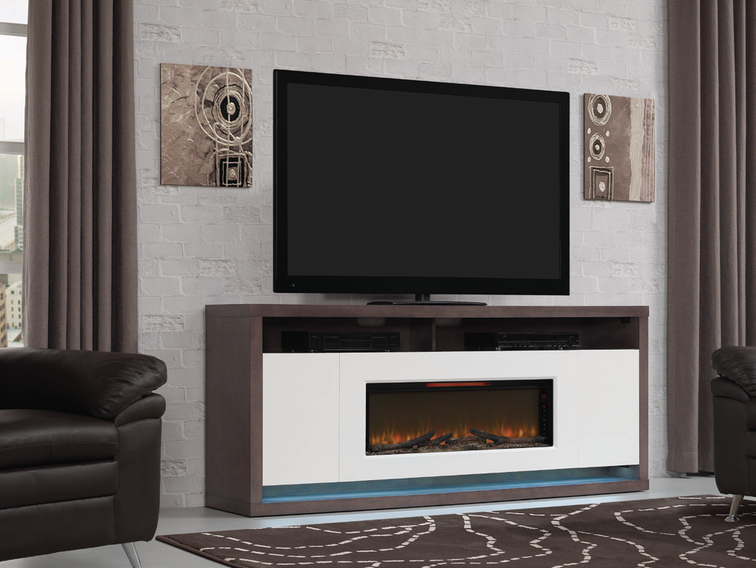

26MM8546

This media mantel will become and instant focal point while establishing a cozy gathering spot in any room of your home. The industrial patchwork riveted aluminum and functionality of the ample storage space make this piece an artistic and practical addition to any home.

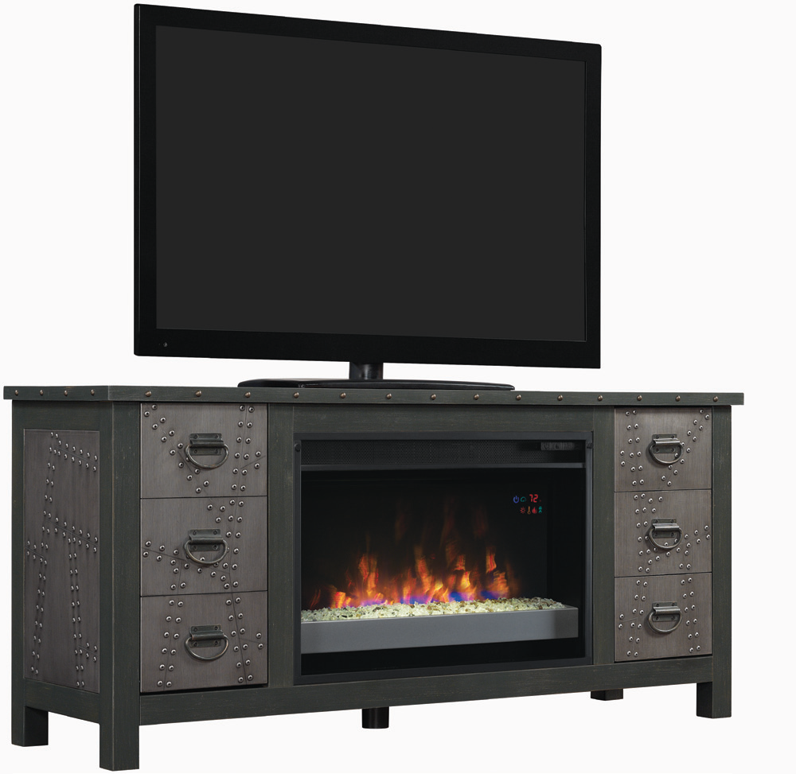

26MM8552-55R1.0-C296 (GRAINGER)

The Grainger is an industrial style media mantel finished in Old World Brown that features wood and steel details. Its open side shelves are excellent for storing media components and showcasing books and picture frames. Complete the look with a 26" ClassicFlame Electric Fireplace Insert with a flame effect that can be operated with or without heat, providing the ambiance of a gentle rolling fire all year long.

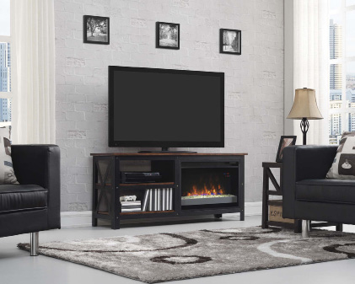

26MM4964-60R2.0-C296 (LANDIS)

The industrial styling of the Landis finished in Old World Brown has blended metal and wood to make a perfect media mantel for any room in your home. Two side cabinets with wood framed doors with metal screen inserts feature adjustable shelves that can be removed if needed for additional storage. Integrated wire management makes organizing electronic components, DVDs and game consoles easy. This mantel is built to hold a flat panel TV up to 65" (115lbs). Complete the look with a 26" ClassicFlame electric fireplace insert.

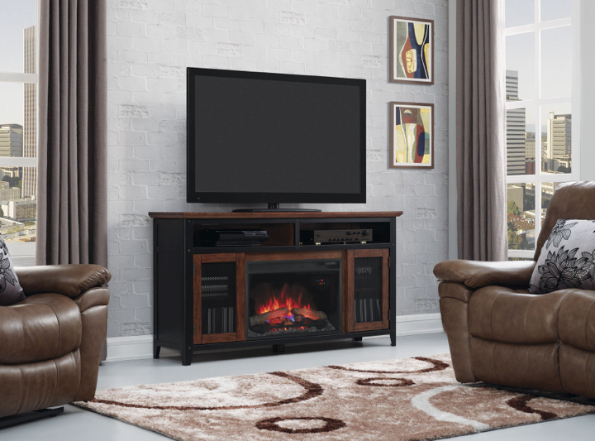

26MM5591-M319

This media mantel boasts an industrial chic style, while creating ample storage space for all of your media components. The two side cabinets with adjustable shelves are perfect for creating custom storage options, while the two side drawers provide additional storage. The sound bar above the realistic fire features two main speakers with Bluetooth capabilities, as well as A/V connections for a hard-wired connection, making this the perfect media mantel for your entertainment needs.

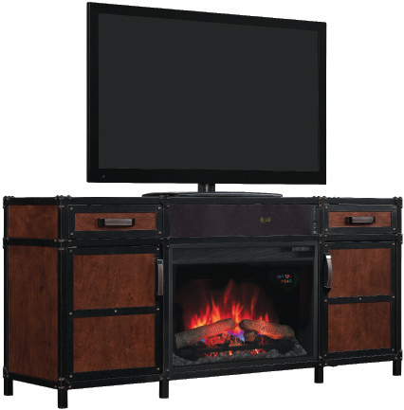

33WM10278-G475

This stunning wall mantel is sure to be the tour stopper in any room of your home. The blue butterfly granite mantel top and surround seamlessly integrate with the Graystone finish. The metal grate front compliments the fine detailing of this mantel. Fluted pilasters, elegant egg-and-dart molding and the center Modena onlay add to the traditional styling of this mantel.

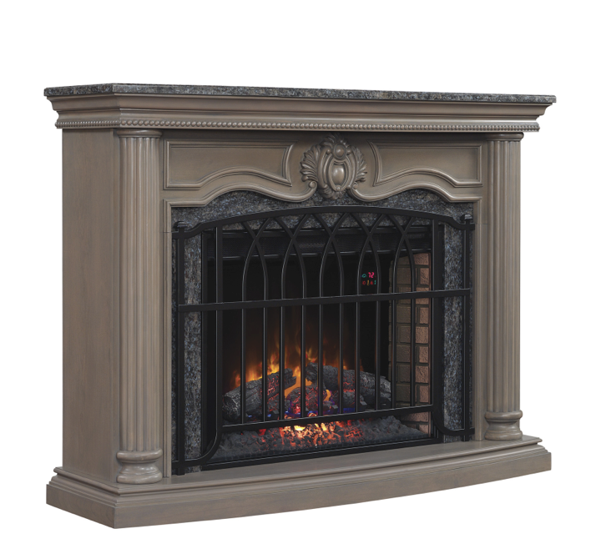

KI10289-P104

This kitchen island allows for functional storage and organization while creating a stylish centerpiece in your kitchen. The sleek black galaxy granite top flawlessly integrates with the Antique Pine finish and the two display cabinets with glass and wood cabinet doors. The stemware storage rack stores all of your stemware, while the slotted wood shelves provide storage for up to 12 wine bottles. The wooden shelves can be turned over to use the flat surface for additional kitchen storage. The top, partitioned shelf is perfect for storage of every day items to keep them close at reach. This kitchen island also features a breakfast bar to create added seating in your kitchen.

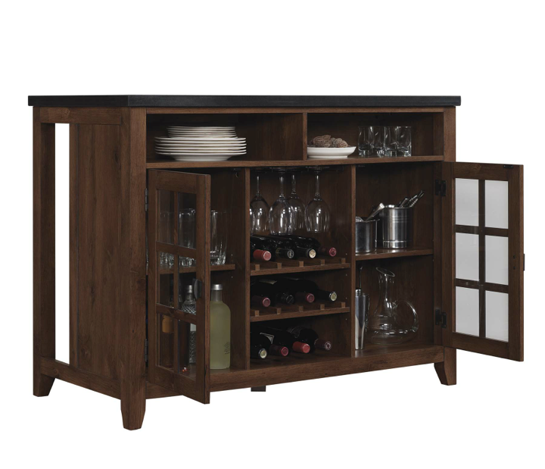

KI5621-PO22 (CHEF)

The Chef Kitchen Island is the perfect way to add functionality and extra storage space to your kitchen. Several drawers allow for tidy storage of your kitchen items, while the pull out trash bin keeps your garbage out of sight. The open shelf allows for storage of every day items to keep them in arm's reach, while the other side of this kitchen island has a built-in pot rack to free up cabinet space and make your pots and pans easily accessible.

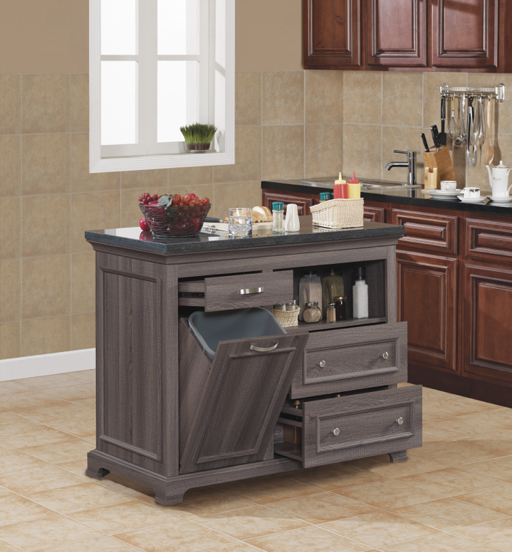

TC-71-9814

This modern media center is sure to become the focal point to any room of your home. The sleek 8mm glass top seamlessly integrates with the glossy finish of the media center. The two drawers and left side storage cabinet provide ample storage space, while the glass front extending above the drawers over the storage shelves allow for easy access to your of media components.

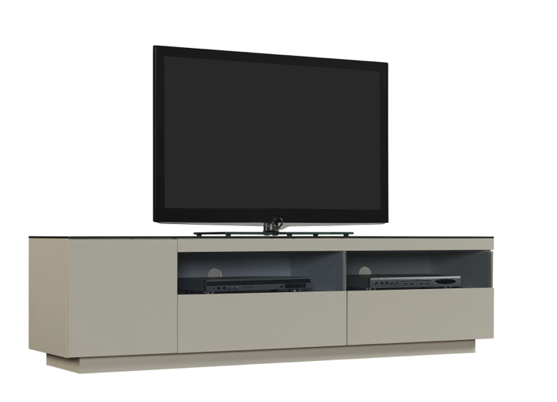

ODP9786-W509 & ODP9786-O128

The Arts and Crafts styling of the Dakota murphy desk has a concealed desktop surface that flips down and converts to a fully-functional desk or closes for workspace tidiness. Features include a black, faux leather inset writing surface that ensures no transfer from pens or pencils and an integrated power strip with two three-prong outlets and two USB charging ports. The bottom cabinet opens to reveal a filing cabinet drawer and a slide-out wooden shelf that is perfect for printer storage.

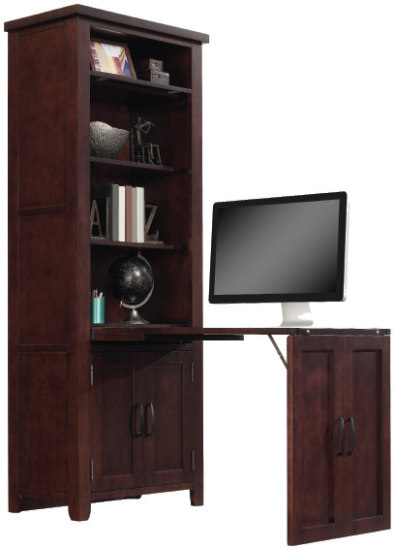

CC9782 Brut Wine Cabinet

As sophisticated and luxurious as fine wine, the Brut curio display cabinet will become a stylish addition to your living or dining area. Display your collectibles in ample display space with glass shelving, or with the wooden shelves that can be used as a flat surface. The wooden shelves can be turned over to use the slotted side to display a wine collection up to 36 bottles. This cabinet is illuminated by LED touch lighting to highlight any display. The curio cabinet door slides open barn-style to provide a new-age chic style, while functionality is not compromised with the deep full extension drawer and the 14 bottle open wine storage below. The gorgeous finish adds a luxurious and classic appeal that compliments any room style.

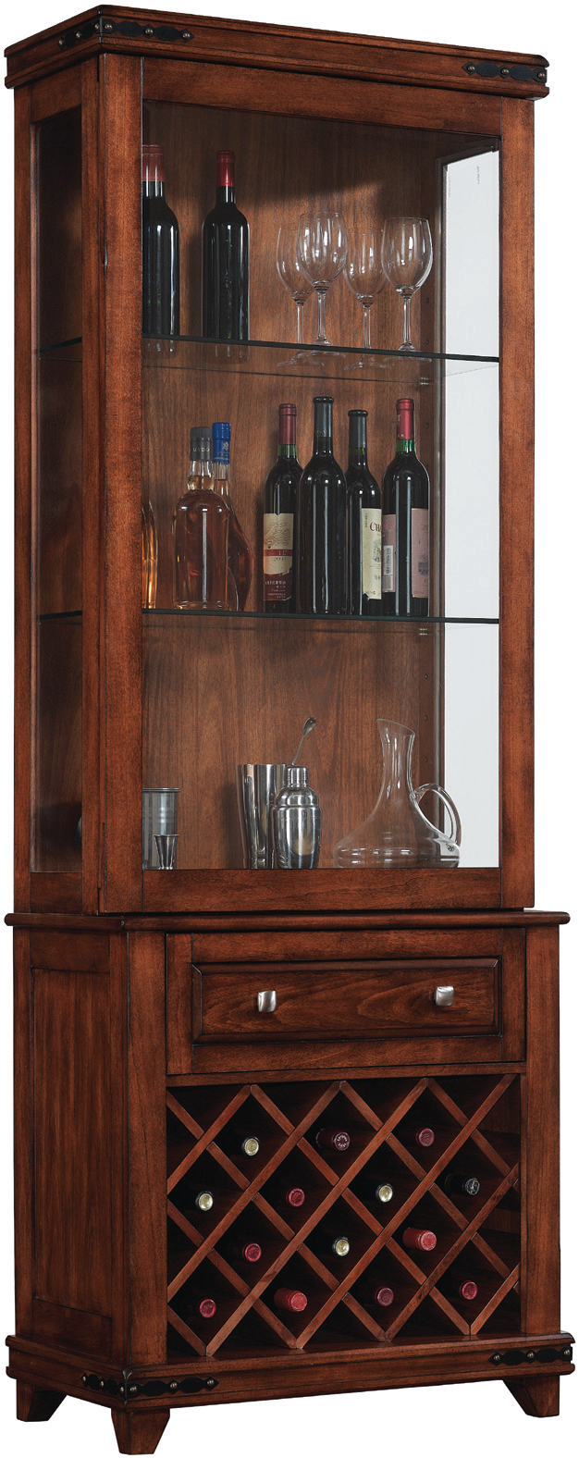

CC8669-C227

This curio cabinet will give lots of room to store and display your finest small sculptures, vases, and artwork in front of a 5mm glass back mirror. Protect your favorite pieces behind strong tempered glass doors and on sturdy glass shelves. A sleek leather wrapped frame creates a simple accent that is a stylish addition for your home. Easy push-to-open glass doors leave hardware to a minimum, and LED touch lighting is perfect for highlighting your most prized possessions. Additionally, a hidden compartment keeps your most valuable treasures hidden away for safe keeping.

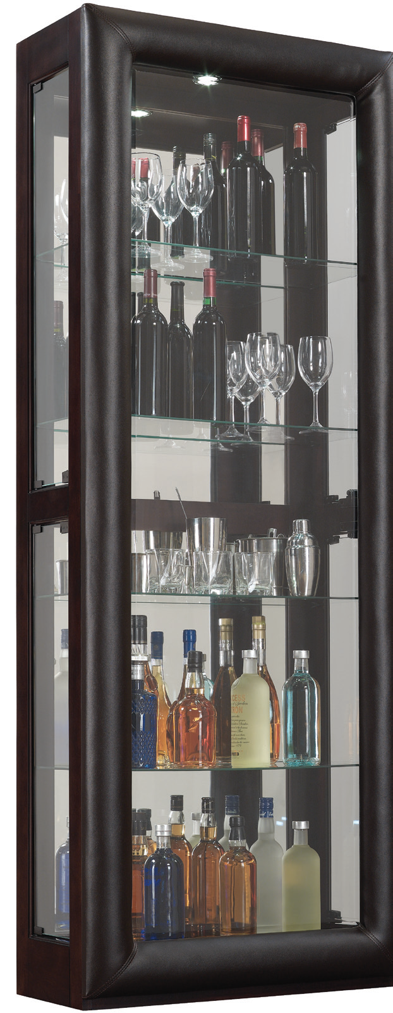
CC20236-E451

Some household pieces are as lovely as they are practical and the beauty they can add to a home is yours for the arranging. Bring an instant and dramatic update to your home with this versatile curio cabinet. Whether you seek a fancy alternative to the bookshelf or need a place to display your fine china, this cabinet is a tasteful solution. Tempered glass shelves allow your valuables to take center stage, accentuated by a depth-creating mirrored back. The LED touch lighting helps display your collection behind the striking leather wrapped frame with exposed rivets.

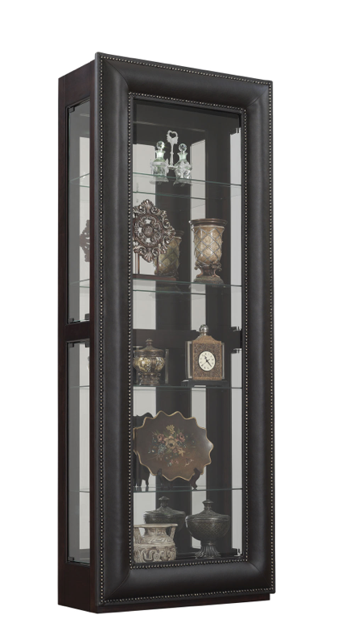

CC5587-X336

With stylized accents and a warm classic finish, this curio cabinet will be the perfect place to showcase your collectibles and memorabilia. The front door of this curio cabinet slides in both directions for easy access to the shelves, while the tempered glass shelves display your collection in front of mirrored glass. The LED touch lighting is perfect for highlighting your possessions while being protected behind the tempered glass cabinet door. Additionally, a hidden compartment keeps your most valuable treasures hidden away for safe keeping.

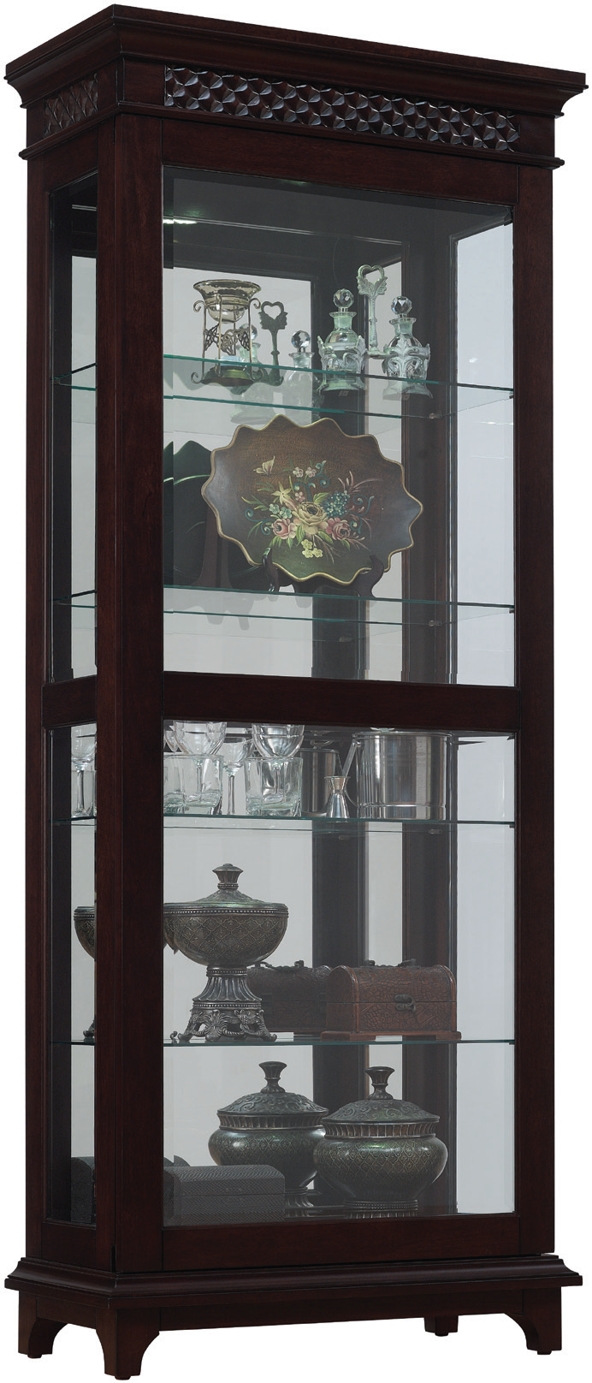

26MM5580-X336

This stunning media mantel is a functional addition to any room in your home. The faux drawers open as cabinets with adjustable shelves, allowing you to store away the clutter. The open, center shelf is perfect for storage of media components. The gorgeous hardware and striking finish of this media mantel make this piece an instant focal point in any room.

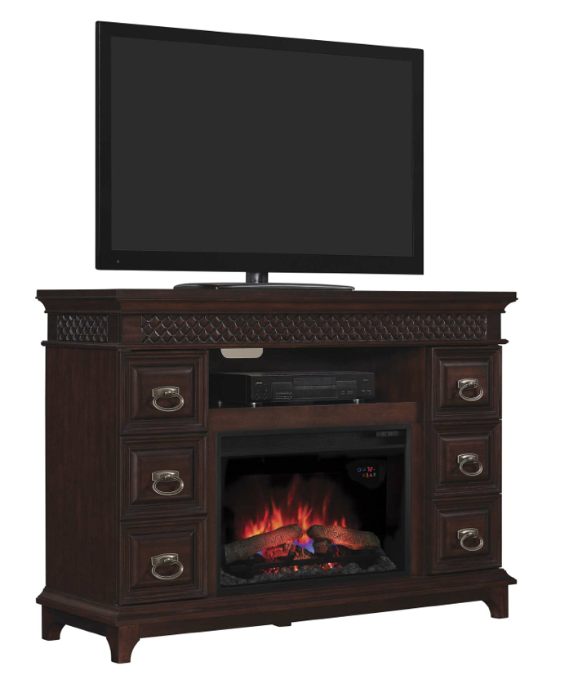

23MM7700-X337

The Hudson media mantel provides ample storage space, as well as a natural focal point in any room of your home. The simple design of this media mantel allows for flawless integration into many room styles, while the functional storage space gives ample room for storing away the clutter. The open, center shelf allows for storage of media components, while the faux drawers conceal two side cabinets with adjustable shelves.

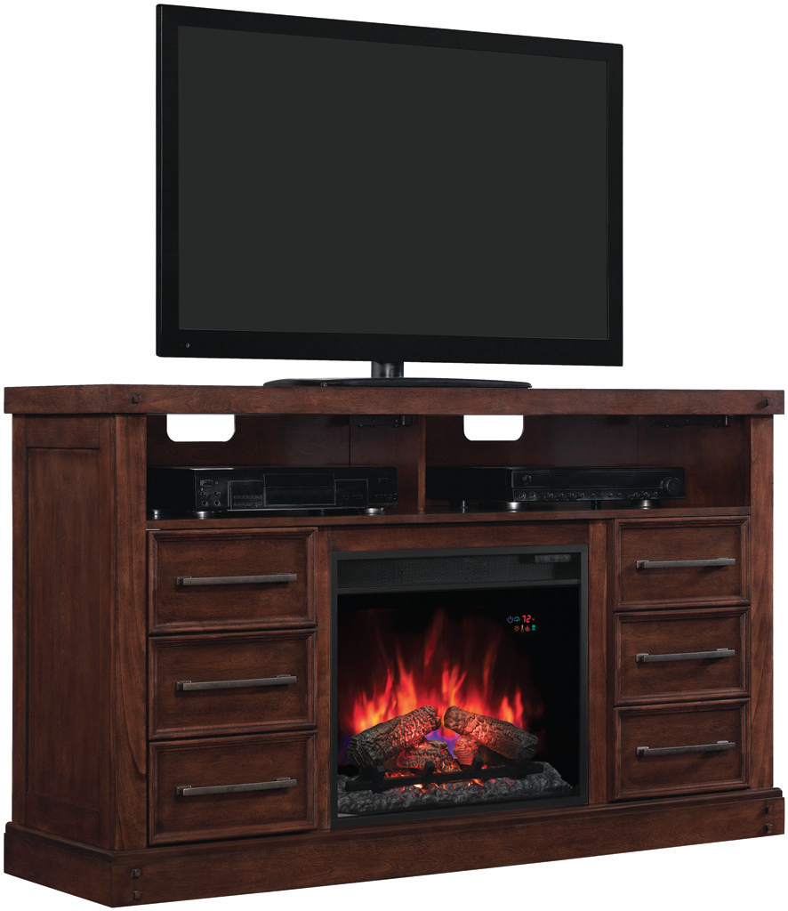

SPR-L6445-20, TPU6445-22, BPL6445-48, 26MM6445, Console, BPR6445-18

The Eastbrooke Collection lets you pick and choose furniture pieces to make a customized unit that makes perfect sense for you and your home. Begin with our Eastbrooke media mantel- either with a fireplace or with storage space- and build your unit by adding side piers. The side piers feature different choices, such as an 18 bottle dual zone thermoelectric wine cooler, beverage cooler, or just an additional storage space. All piers offer interchangeable glass or wood door panels, soft close European hinges, and adjustable shelves. The stunning blue butterfly granite top is the cherry on top of this gorgeous collection.

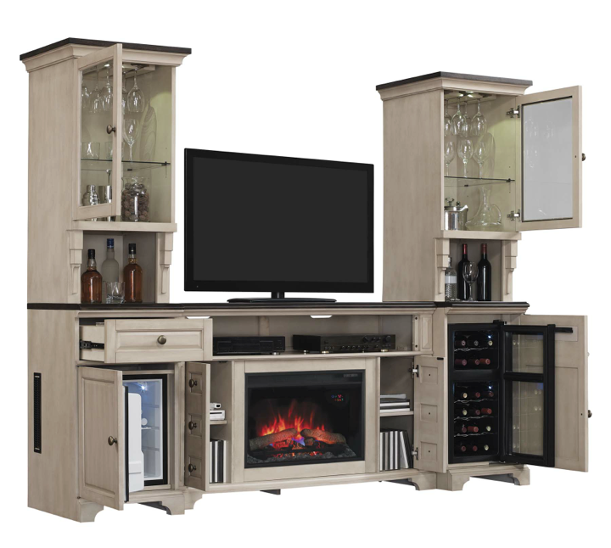

TC58-9789-PB86

The modern design of this media cabinet creates a sleek home for a flat panel TV and components. The media console cabinet offers a space-saving design, two side cabinets for component and media storage, and gorgeous tempered glass doors. The open center shelf is perfect for vented storage of media components. Use the sound bar with A/V inputs and Bluetooth capabilities to play your favorite music, or to get big sounding audio on your television programs.

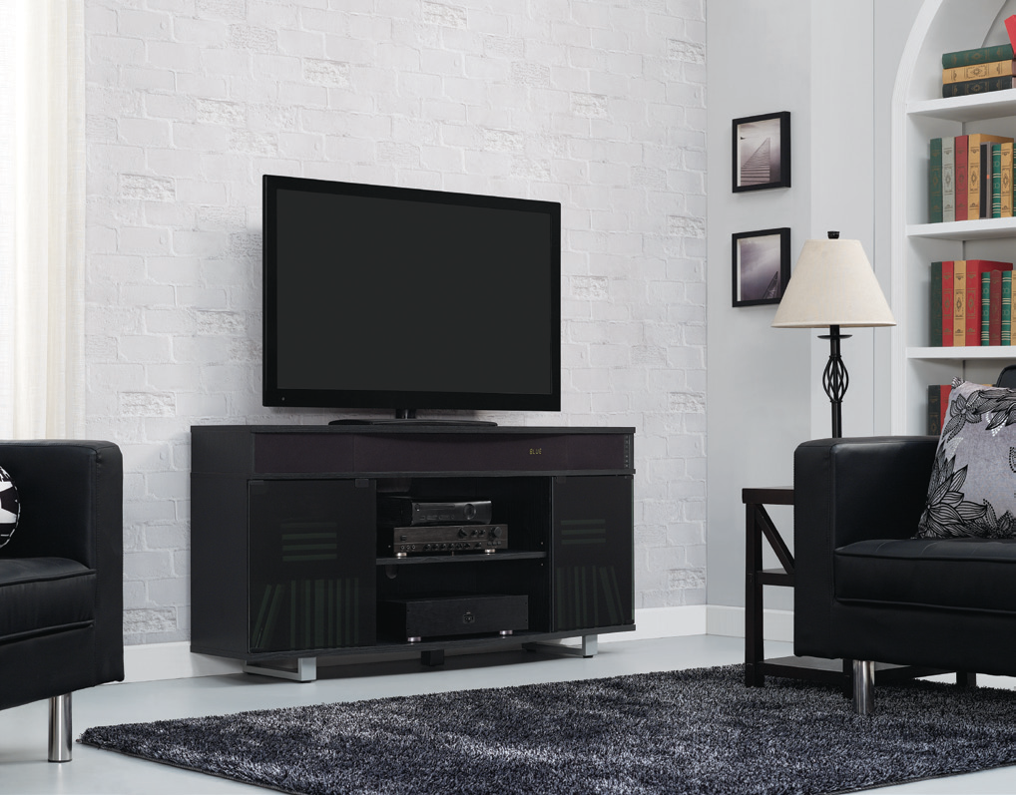

TC-71-9813

This media console boasts a contemporary style with three drawers and three shelves for ample storage space. The 5mm glass cleverly extends above the drawers and along the sides to encompass the storage shelves, which seamlessly integrate with the 8mm clear glass top of this media console.












