

FOR IMMEDIATE RELEASE Contact: Mary Leigh Howell
SHOWROOM: 101 S. Hamilton ml@maryleighhowell.com
(336) 317-7713

Universal Furniture’s Birchaven Collection is a Love Letter for the Home

IMAGES: https://www.dropbox.com/scl/fo/09moyxgp8oalcezu0qlov/AJWFbJvOmqzdtykoxdcOtrQ?rlkey=cxaxwo62skijaaxhwusk67kb7&st=8kbwrfne&dl=0

HIGH POINT, N.C., October 21, 2025 - With its timeless silhouettes, light wood tones and accent pieces that feel collected rather than coordinated, the Birchaven Collection may be the most agreeable and versatile furniture offering ever introduced by Universal Furniture. The collection, new for October Furniture Market, brings effortless comfort and quiet style to transitional living, all but guaranteeing its success with a wide range of designers and retailers.

“Birchaven is designed to feel fresh, livable and timeless, whether customers style it in a coastal retreat or even a contemporary home,” said Sean O’Connor, president of Universal Furniture. “There is broad appeal in a collection with this much depth of product and detail, and we think our customers will be excited by its possibilities.”

Birchaven is best described as a love letter to classic transitional living. The collection’s furniture silhouettes feature a modern neoclassical influence and are available in two signature wood finishes: Willow and Brindle, both characterized by crisp, consistent clarity and durable construction. Birch wood is at the core of the collection, hence the Birchaven name, and provides a strong base that is resistant to dents but has a fine-grained texture and a consistent finish, free from knots or burls.

The collection layers tactile accents, including twisted abaca for an artisanal texture, white quartz for refined surface interest and a textured wallpaper finish that elevates many of the pieces and achieves a unique aesthetic. An aged pewter metal finish acts as the jewelry that ties the collection together.

The Birchaven Collection comprises more than 77 casegood pieces, featuring versatile bedroom, dining, and occasional furniture, as well as coordinating silhouettes and finishes for easy layering. Some of the product highlights include:

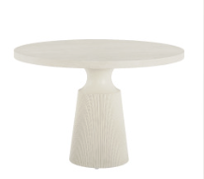
Birchaven Pedestal Table
With its small, unique 44-inch diameter, this round pedestal table is ideal for entryways or breakfast rooms, and works well in urban spaces and older homes. Below the petite surface, the narrow pedestal neck widens into a reeded base.

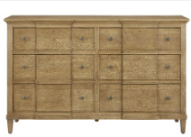
Birchaven Brindle Dresser
Appearing as two, side-by-side chests, the Brindle Dresser sits on tapered legs and has a dapper vibe. The double breakfront configuration features six drawers, one of which is equipped with a black felt-lined jewelry tray, outlined in beaded trim molding. An escutcheon adds a quaint touch.

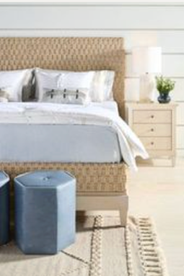
Birchaven Woven Abaca Bed
The humble abaca is elevated to an art form in the Woven
Abaca bed. Multi-strand basketweave patterns cover the
headboard, footboard and rails. The effect is striking,
but the natural abaca tones soften the drama, creating a
textured yet restful appearance. Available in King size only.

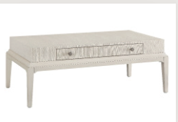
Birchaven Meadow Cocktail Table
With its lean, rectangular shape and tapered legs, the Meadow Cocktail Table offers surface area, storage and a unique wallpaper-textured finish that brings a natural element to any space.
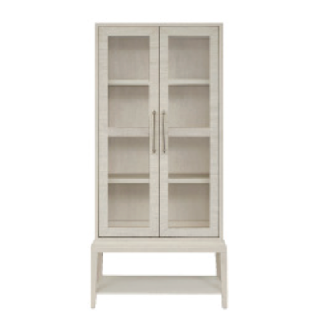

Birchaven Meadow Display Cabinet
Measuring an impressive 80 inches in height, the Meadow Display Cabinet boasts a textured wallpaper finish that has elegant surface interest. Aged pewter metal pulls add a finished touch that ties the cabinet together, making it an understated yet regal storage solution.

Birchaven Upholstery
The majority of Birchaven’s new upholstery designs are bench made in North Carolina, where artisans build and assemble all the frames in house. In early 2026, a new, Samson-Marketing owned upholstery facility located in Hildebran, North Carolina, will be fully operational. The new location allows Universal’s upholstery operations to be on one level, giving the manufacturing process a more efficient flow in production.

The domestic facility gives customers the ability to select one of 500+ stocked fabrics, 100+ leathers or COM. Customers can try out fabric and leather selections for each design using Universal’s online 360-degree draping tool, which takes the mystery out of how a fabric pattern will scale when applied to a sofa, chair, ottoman or bedframe.

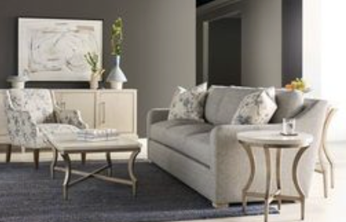
Filmore Sofa (and suite)
An elegant, tailored slope arm is paired with plush down feather seats and backs, and dressed in a tonal, multi-textured fabric with accents of pale blue, ivory and taupe.

Filmore is a broad collection which includes multiple sofa, chair and sectional configurations and can be fully upholstered or slipcovered in 500+ stocked fabrics along with COM options.

Stella Accent Chair
The Stella chair, a tailored silhouette sitting pretty on customizable birch legs, and elegantly dressed in a multi-layer jacquard textile featuring a painterly blossom design. Like all Universal bench made upholstery, Stella is offered in more than 500 stocked fabrics, COM and 100+ leathers.

About Universal
Retailers and interior designers around the world trust Universal Furniture’s award-winning, smart and stylish designs to create modern, well-appointed living spaces for the whole home. The company’s casegood, upholstery, accent and outdoor designs are developed under the brand names Universal Furniture and Coastal Living.

Universal Furniture, founded in 1968 and based in High Point, N.C., is the recipient of 14 Pinnacle awards for design excellence from the International Society of Furniture Designers. It is a brand of Samson Holdings, one of the world’s largest vertically integrated furniture manufacturers. For more information, please visit www.universalfurniture.com, or find us on Facebook, Instagram, and Pinterest.

# # #

