

FOR IMMEDIATE RELEASE Contact: Mary Leigh Howell
SHOWROOM: 101 S. Hamilton ml@maryleighhowell.com
(336) 317-7713

MODERN MIST & VEIL: NEW ADDITIONS ENLIVEN
ONE OF UNIVERSAL’S MOST SUCCESSFUL COLLECTIONS

IMAGES: https://www.dropbox.com/scl/fo/09moyxgp8oalcezu0qlov/AJWFbJvOmqzdtykoxdcOtrQ?rlkey=cxaxwo62skijaaxhwusk67kb7&st=8kbwrfne&dl=0

HIGH POINT, N.C., Oct. 21, 2025 – What began nearly 10 years ago as a strategic move into modern-day interiors has evolved into a wildly successful and enduring group of furnishings known for its bold lines and simple forms. Modern by Universal presents the fall 2025 collection under the moniker of Modern Mist & Veil.

Modern Mist & Veil distills luxury to its essence—quietly powerful silhouettes rendered in two core finishes. Mist, a soft light oak, and Veil, a rich dark oak, set a striking backdrop, while Haze, a figured walnut accent with a clear, subdued finish, adds organic movement. Elevated material moments-White Quartz, Pyrite, Emperador stone and smoked gold metal infuse the collection with a refined glow. Sculptural cast aluminum and leather finishes create depth and dimension across bedroom, dining, and living.

Universal’s first Modern Collection debuted in October of 2016, with Mist & Veil being the sixth addition. The group has remained true to its origins, and the ethos established in the first collection applies today: “a clean and simple collection that’s bold and a bit daring. It honors its roots in Modernism but doesn’t replicate mid-century style. The focus is on livability and usability, making it comfortable enough for every day.”

Modern has become a defining element of the Universal brand. Since 2016, Modern has consistently delivered designs and price points that help retailers succeed in offering their customers a very high-end look at a value-driven price.

Some of the highlights in the Modern Mist & Veil Collection include:
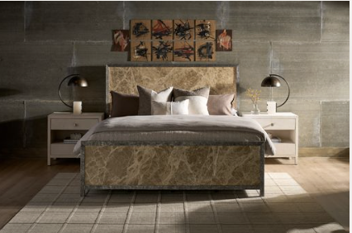
MODERN Mirage Bed
The dramatic headboard, footboard and rails take center stage in the Mirage bed with slabs of Emperador marble, trimmed in cast aluminum with a sandblasted wood texture. The marble, quarried in Spain, is a stunning swirl of creams, browns and beiges that blend effortlessly and feature a long-lasting surface shine. The effect is earthy and warm with a sun-kissed glow. Available in king size only.

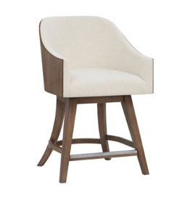
MODERN Haze Swivel Counter Stool
With an upholstered seat interior and walnut-wrapped jacket back, the Haze Swivel Counter Stool feels a bit mid-century. Front legs feature a metal footrest to protect the wood, while back legs are splayed for style and support.
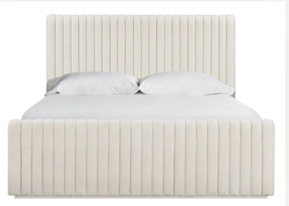

MODERN Strata bed
Like tightly packed clouds, the nearly two dozen upholstered channels give a billowing effect to the Strata bed with a footboard to match. Strata’s footboard sits on a plinth base and has upholstered rails. Upholstered in an off-white Oyster-colored fabric. Available in king and queen size.

MODERN Haze Console
This beauty in figured walnut fits spaces to a T- literally. The T-shaped, cantilevered ends appear to double back on themselves, but it’s an optical illusion achieved by inserting a smoked gold metal accent to bridge the top and the base.
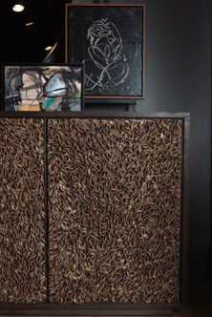
MODERN Blossom Credenza
Available in both light and dark oak finishes, featuring 5,712 hand-shaped leather fleurettes, Blossom appears to grow before your eyes. Four doors with touch-latch hardware are covered in blooms, each hand-applied for a show-stopping effect.

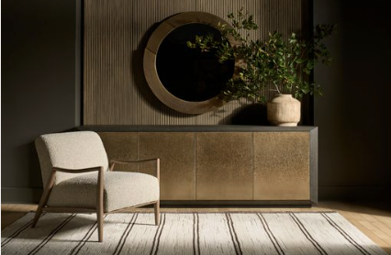
MODERN Nova Credenza (shown with Lucca chair)
An extended, mitered oak case (96 inches long) in the dark oak finish sets the background for four acid-etched, smoked gold metal doors, in a continuous gradient pattern. Magnetic touch latch hardware, internal power bar, and cutouts for wire management.

MODERN Haze Dining Table
This dramatic, 86-inch-long, rectangular formal dining table delivers a modern, yet elegant silhouette in flat cut, figured walnut with angled metal legs that pierce the table surface. Comes with two 18-inch leaves to finish at 122-inches long, 44-inches wide.

MODERN Upholstery
Many of Modern’s 15 new upholstery designs are bench made in North Carolina, where artisans build and assemble all the frames in house. The domestic facility gives customers the ability to select one of 500+ stocked fabrics, 100+ leathers or COM. Customers can try out fabric and leather selections for each design using Universal’s online 360-degree draping tool, which takes the mystery out of how a fabric pattern will scale when applied to a sofa, chair, ottoman or bedframe.

In addition to custom selections, several designs are pre-made and Ready-to-Ship, giving customers quick access to product with covers that appeal to the majority of consumers. Ready-to-Ship designs can be mixed with casegoods for retailers buying direct container.

Dylan Sofa (Made in North Carolina) At 96-inches long and 39-inches deep the modern Dylan sofa can seat several guests. Special attention was paid to the outline of Dylan’s sleek silhouette, with a rounded arm and back rail that signal comfort and a relaxed mood. Two removable seat cushions and a tight back. The accompanying barrel-back swivel chair features the same silhouette.
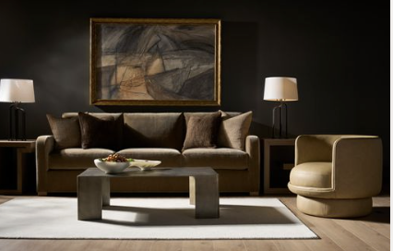
Deke Swivel Chair (RTS) – Modishly round, this fully upholstered barrel back accent chair surrounds a nearly round, fixed seat cushion, and sits on fully upholstered round swivel base. A self-welt underscores its shapeliness. (Deke is shown here with the Filmore sofa.)

Lucca Occasional Chair (RTS)-A wooden frame with shapely arm rest and tapered legs forms the outline of this chair with a generous upholstered seat and back. It’s comfortable enough for the living room but would look smart in a home office as well. Available in a linen-like or boucle fabric.

The Hyde Motion Sofa (RTS) first introduced in spring of this year, is shown in an Italian performance leather for the first time. The style is an expansion on the original design, which was a Pinnacle Award finalist.

About Universal
Retailers and interior designers around the world trust Universal Furniture’s award-winning, smart and stylish designs to create modern, well-appointed living spaces for the whole home. The company’s casegood, upholstery, accent and outdoor designs are developed under the brand names Universal Furniture and Coastal Living.

Universal Furniture, founded in 1968 and based in High Point, N.C., is the recipient of 14 Pinnacle awards for design excellence from the International Society of Furniture Designers. It is a brand of Samson Holdings, one of the world’s largest vertically integrated furniture manufacturers. For more information, please visit www.universalfurniture.com, or find us on Facebook, Instagram, and Pinterest.

