

FOR IMMEDIATE RELEASE SHOWROOM: 101 S. Hamilton

Contact: Mary Leigh Howell
ml@maryleighhowell.com
(336) 317-7713

Universal Furniture Brings European-Inspired Living Stateside
with the Debut of its Fenwick Collection

HIGH POINT, N.C., April 22, 2026 – Inspired by Americans’ love for continental interiors, Universal Furniture is bringing that coveted, travel-inspired aesthetic stateside with the introduction of its Fenwick Collection. An updated take on European Neoclassical design, Fenwick stops just short of traditional and blends classic influences with a more relaxed, livable vibe.

With a lean toward symmetry, restraint and grandeur, Fenwick highlights Neoclassical influence and a time when grand columns, triangular pediments and muted colors were all the rage. The collection features pearly velvet fabrics and a caramel Luminance Caribou leather. While there is a sense of formality to the pieces in the collection, the value, heritage and quiet luxury are in line with what today’s consumers are seeking.

“Our new Fenwick Collection is more on the casual side of traditional in terms of style and feel,” said Sean O’Connor, President of Universal Furniture. “The European influence is very distinct, but Fenwick shows restraint rather than ornamentation.”

Fenwick is crafted from flat-cut birch veneers and features a deep, rich brown finish with a hint of sheen. Accents of embossed raffia serve as a textural element, offering a distinct appearance against the low-sheen wood finish. Select pieces, including a credenza, bachelor’s chest, console and side table are wrapped in the woven surface that hints at fashion and nature. Hardware and table legs with a dusty bronze finish and dark Emperador marble are hallmarks of the collection.

A large collection of 80-plus SKUs, Fenwick encompasses formal and casual dining, formal dining, living room, media room, bedroom and occasional. Highlights from the collection include:
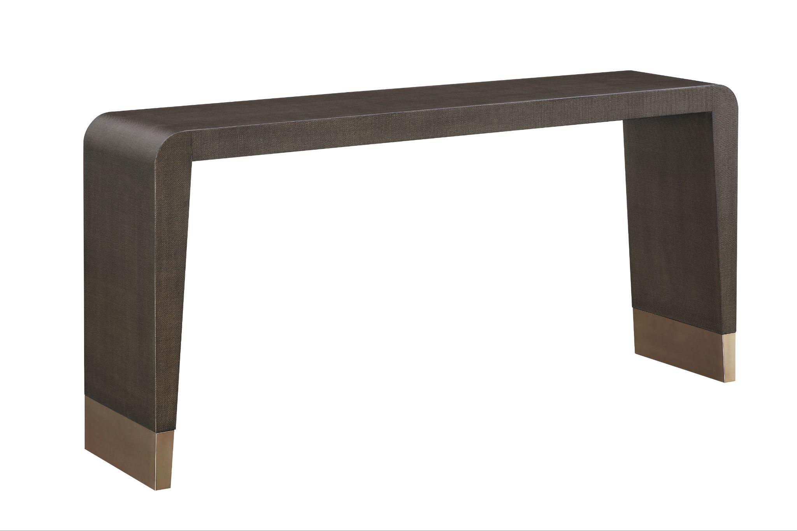

Fenwick Console
With a raffia finish, the console features an angled, tapered spade foot, giving Universal’s consoles a new look inspired by Neoclassical design.
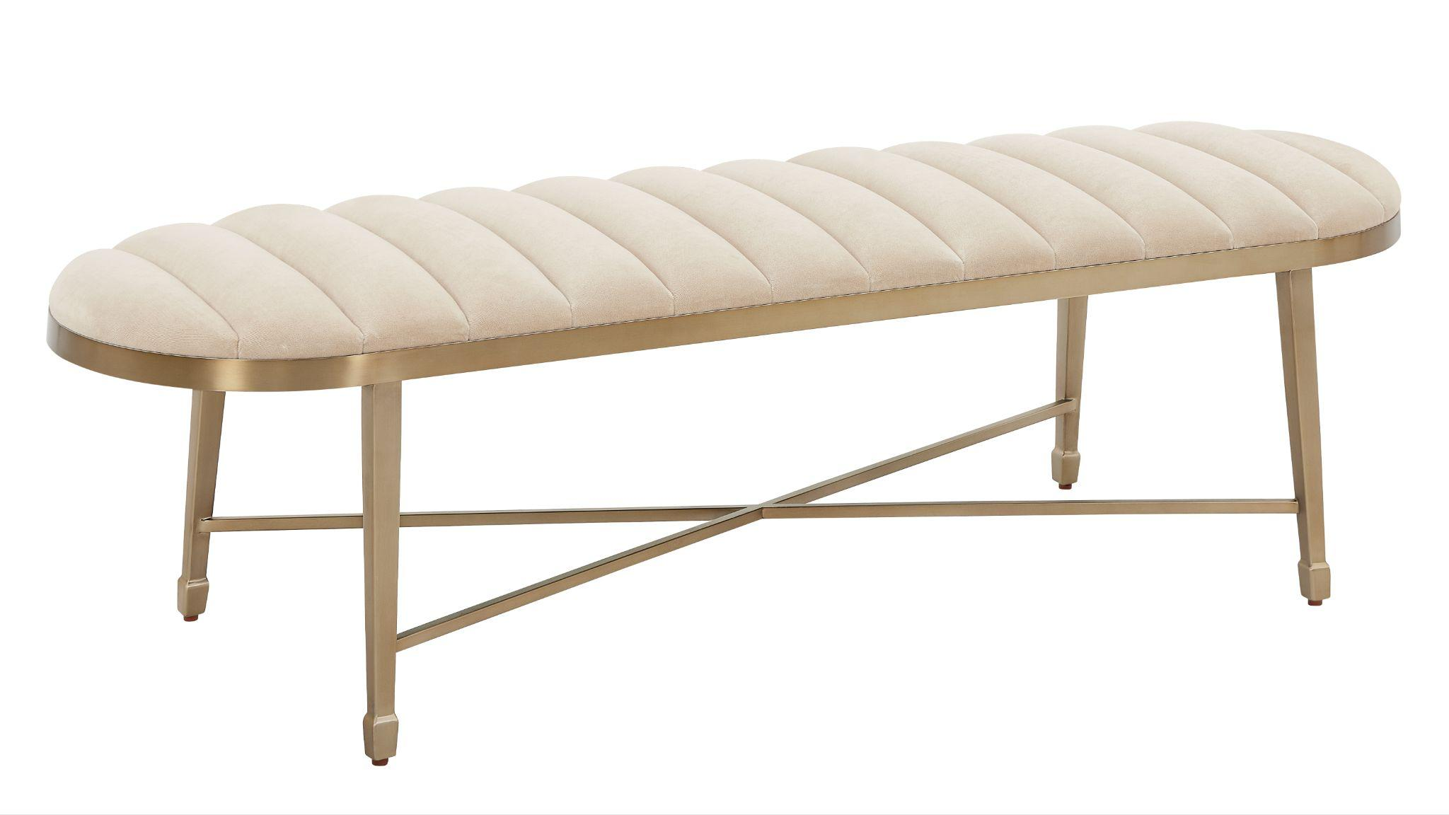

Fenwick Dusty Bronze Bench
This unique pill-shaped bench in Desert Gold finish sits on tapered legs with a stretcher design. The seat is upholstered in a cream colored, channel-quilted velvet.

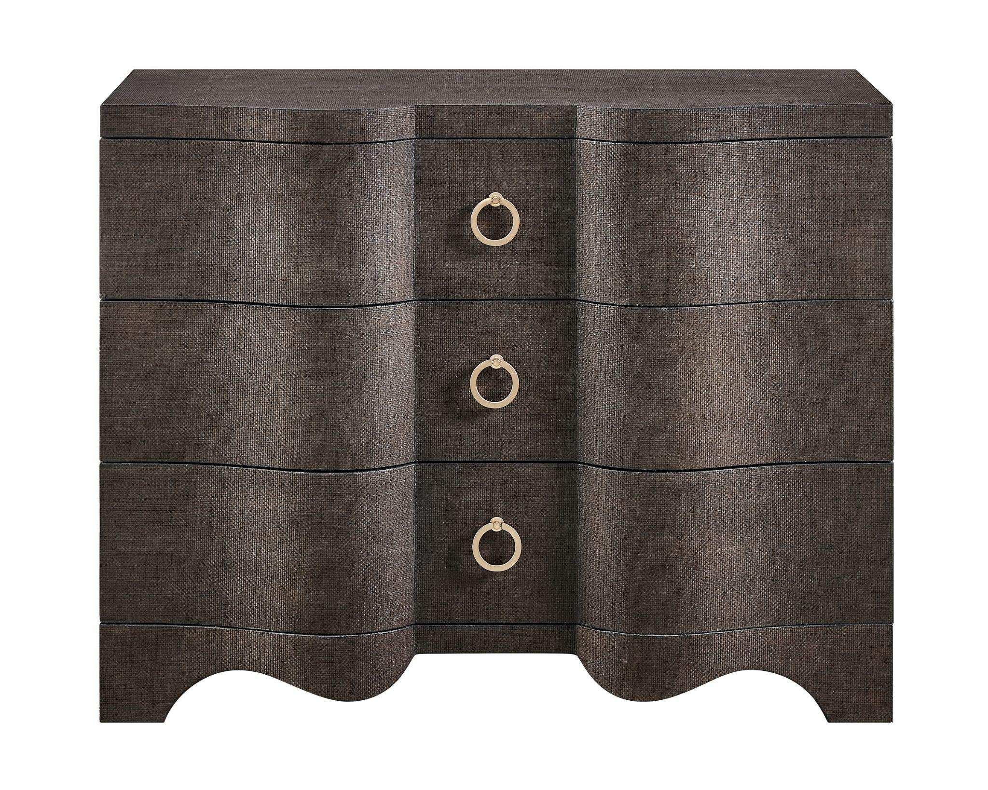
Fenwick Embossed Chest
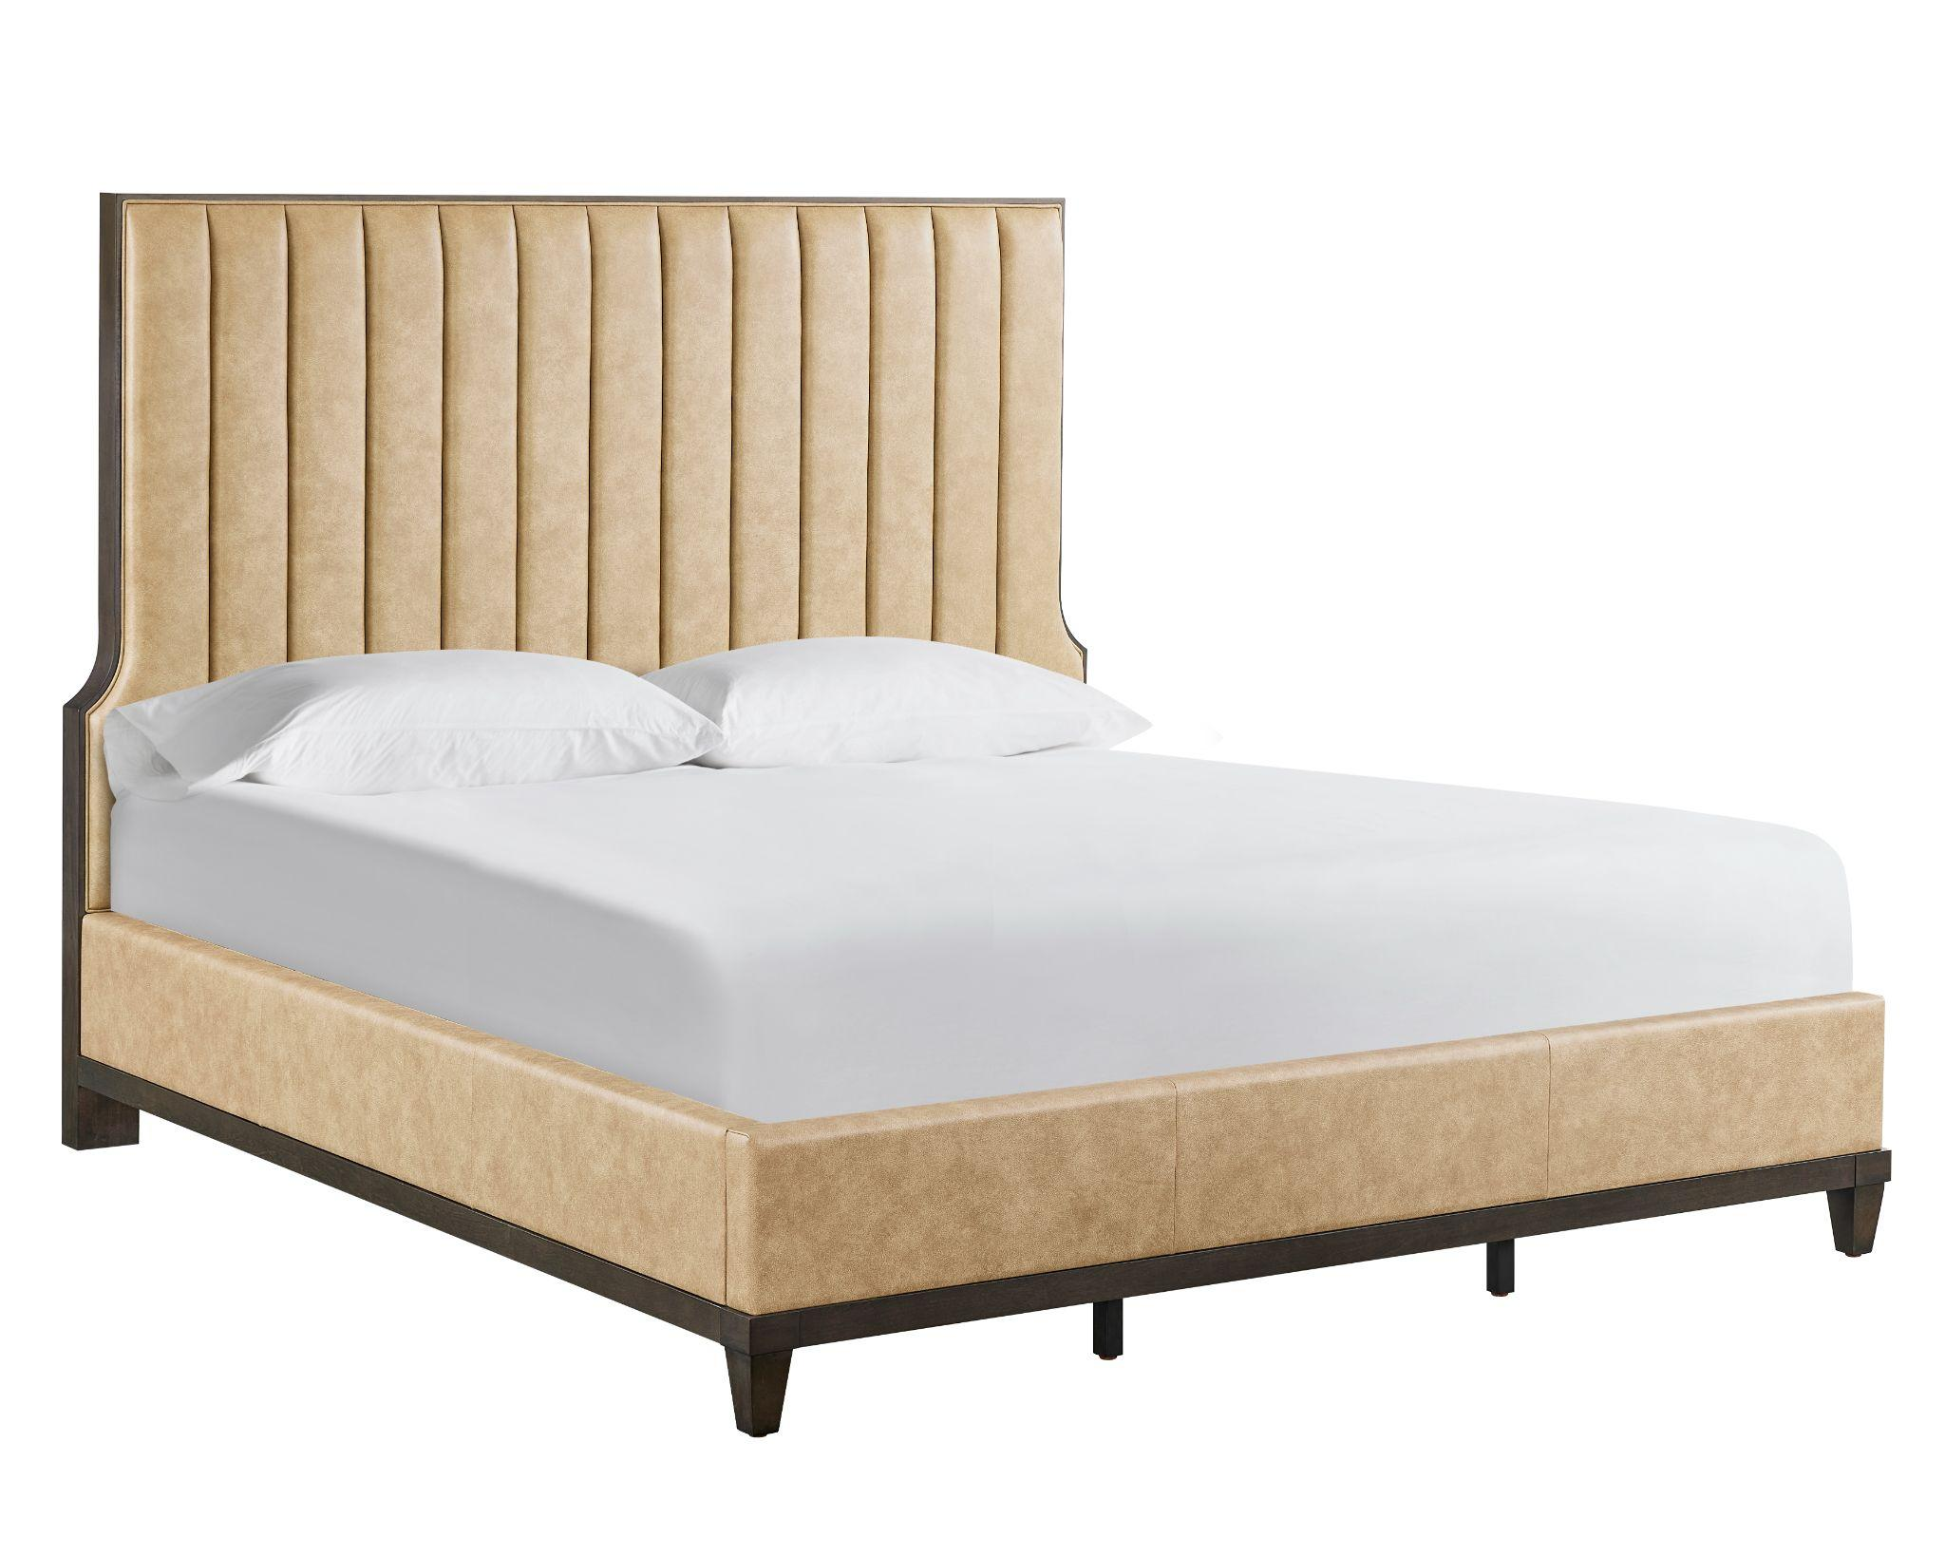
With three drawers and three perfectly situated Dusty Bronze ring pulls, this curvy case has a dark brown textured raffia finish and sinuous shape.

Fenwick Leather Upholstered Bed
Trimmed in wood, the bed’s vertically channeled leather headboard makes a striking statement in any bedroom. A leather-wrapped sideboard and rails sit upon tapered legs.
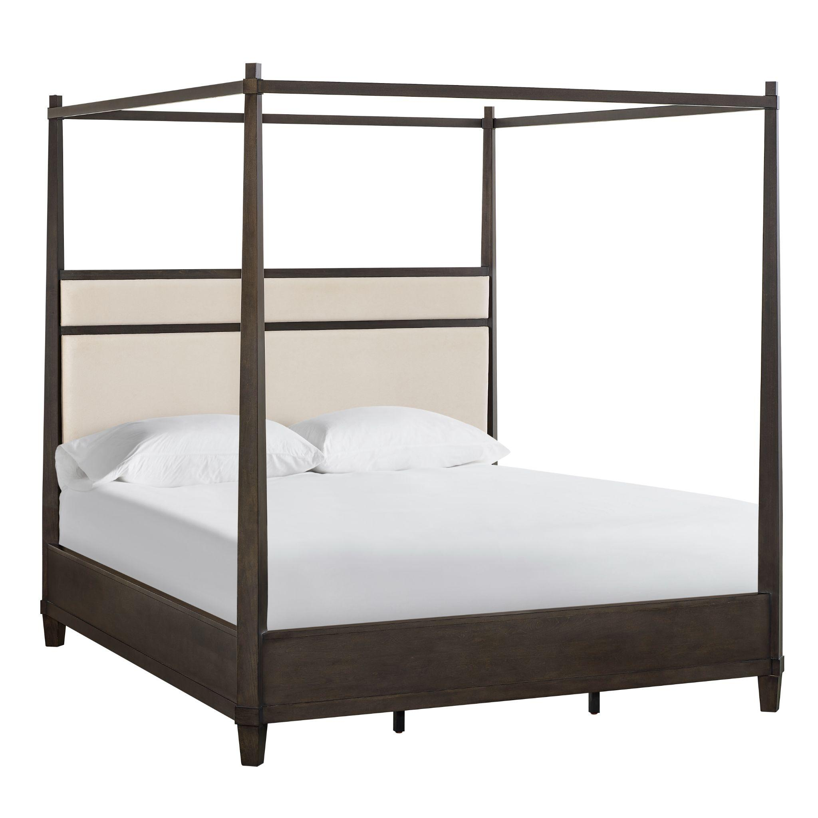

Fenwick Poster Bed
A wood-blocked, upholstered headboard and angled posters (with a square tester, optional) set this otherwise expected design on edge, just enough to provide distinction, but not so much as to distract from its solid, clean lines.
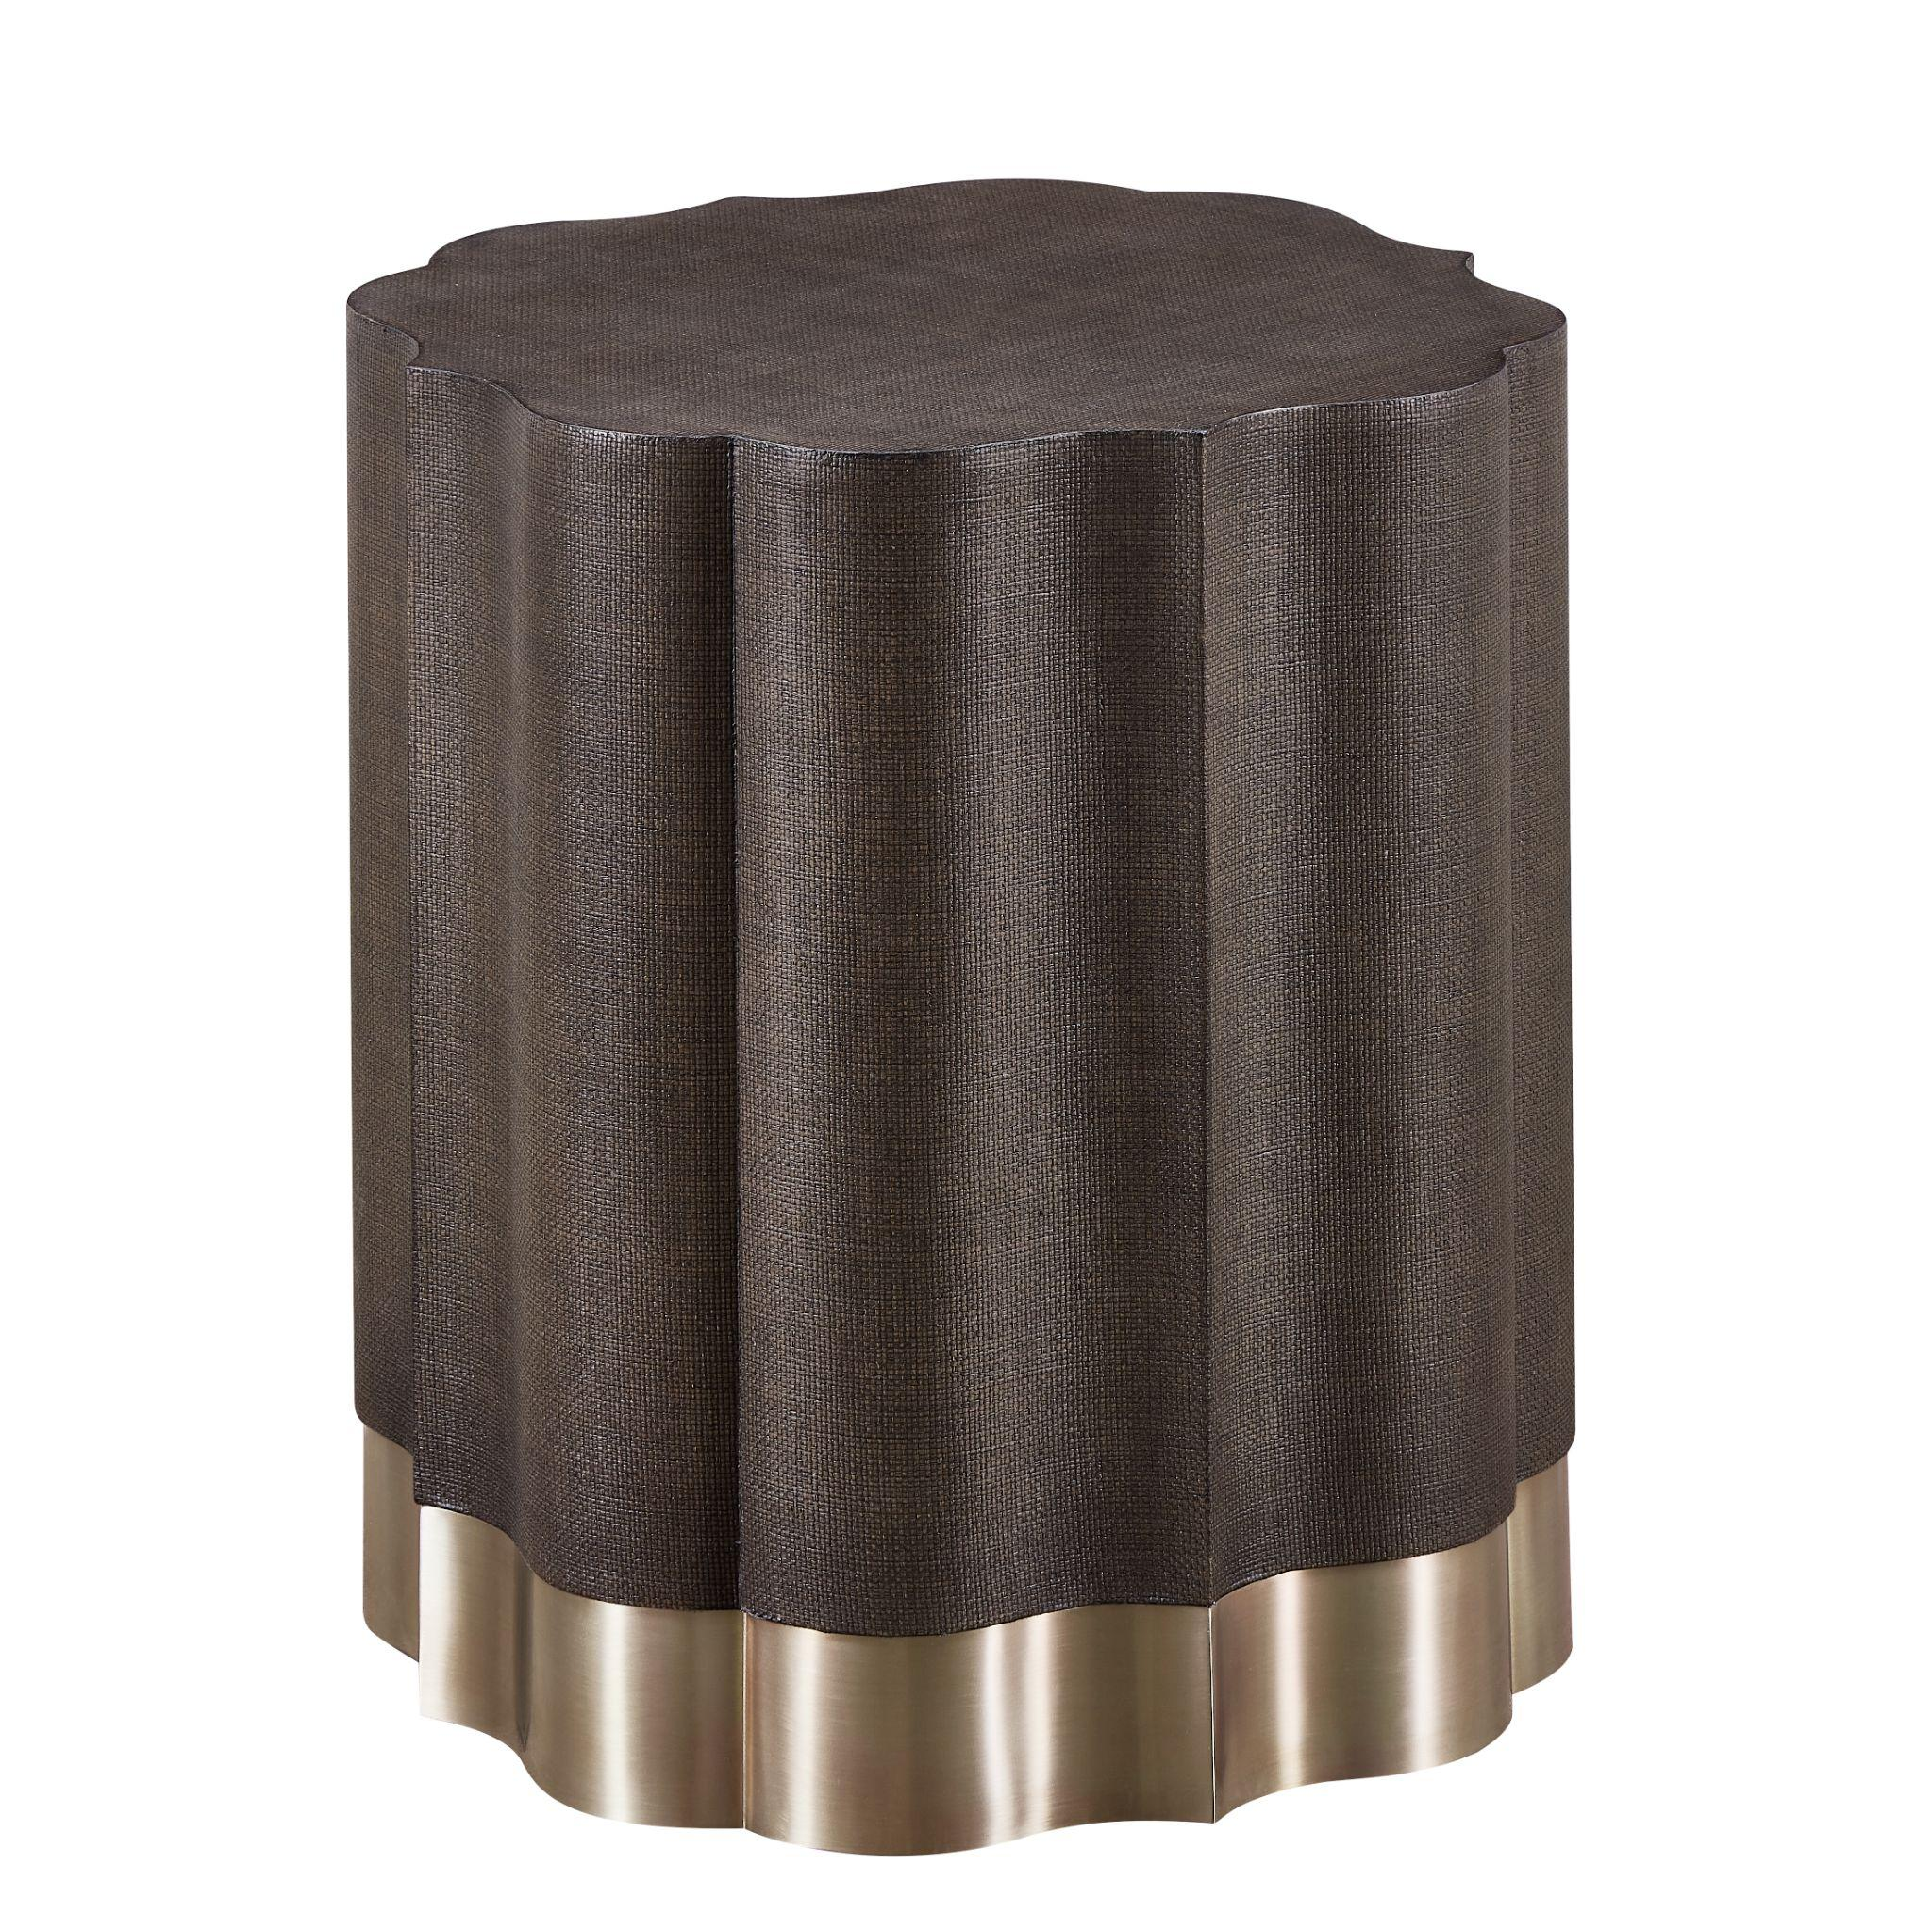

Fenwick Side Table
Sure to be a designer favorite, an ogee shape defines the sinuous sides of this table, with an embossed raffia finish and a Dusty Bronze base.

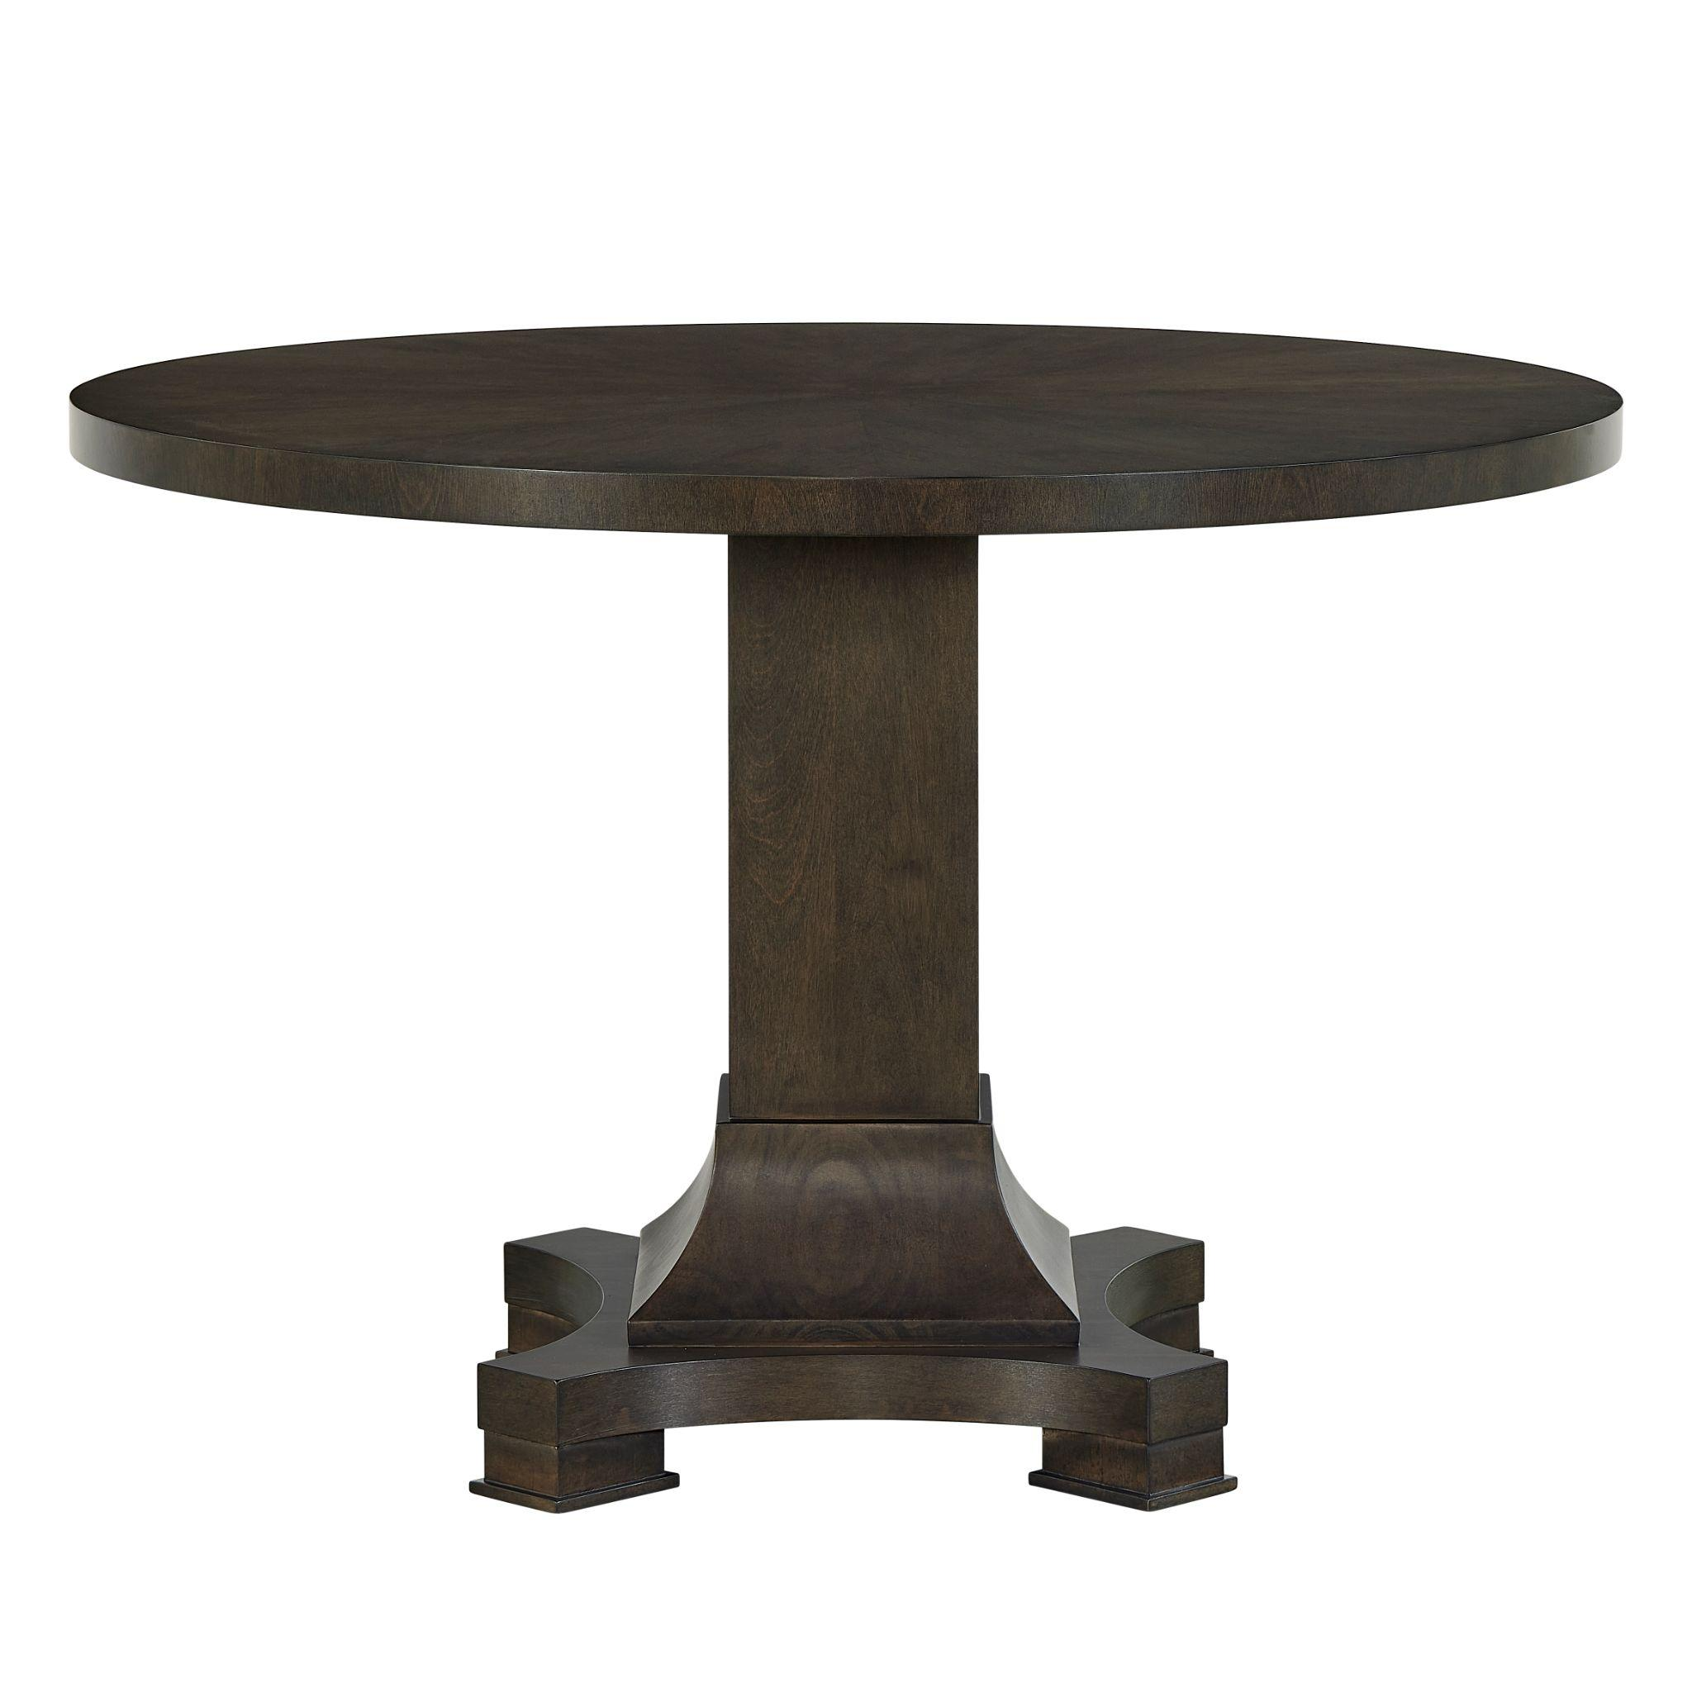

Fenwick Pedestal Table
At 44 inches round, this table is ideal for the breakfast room or foyer. Empire references inform the four feet at the base of the pedestal.
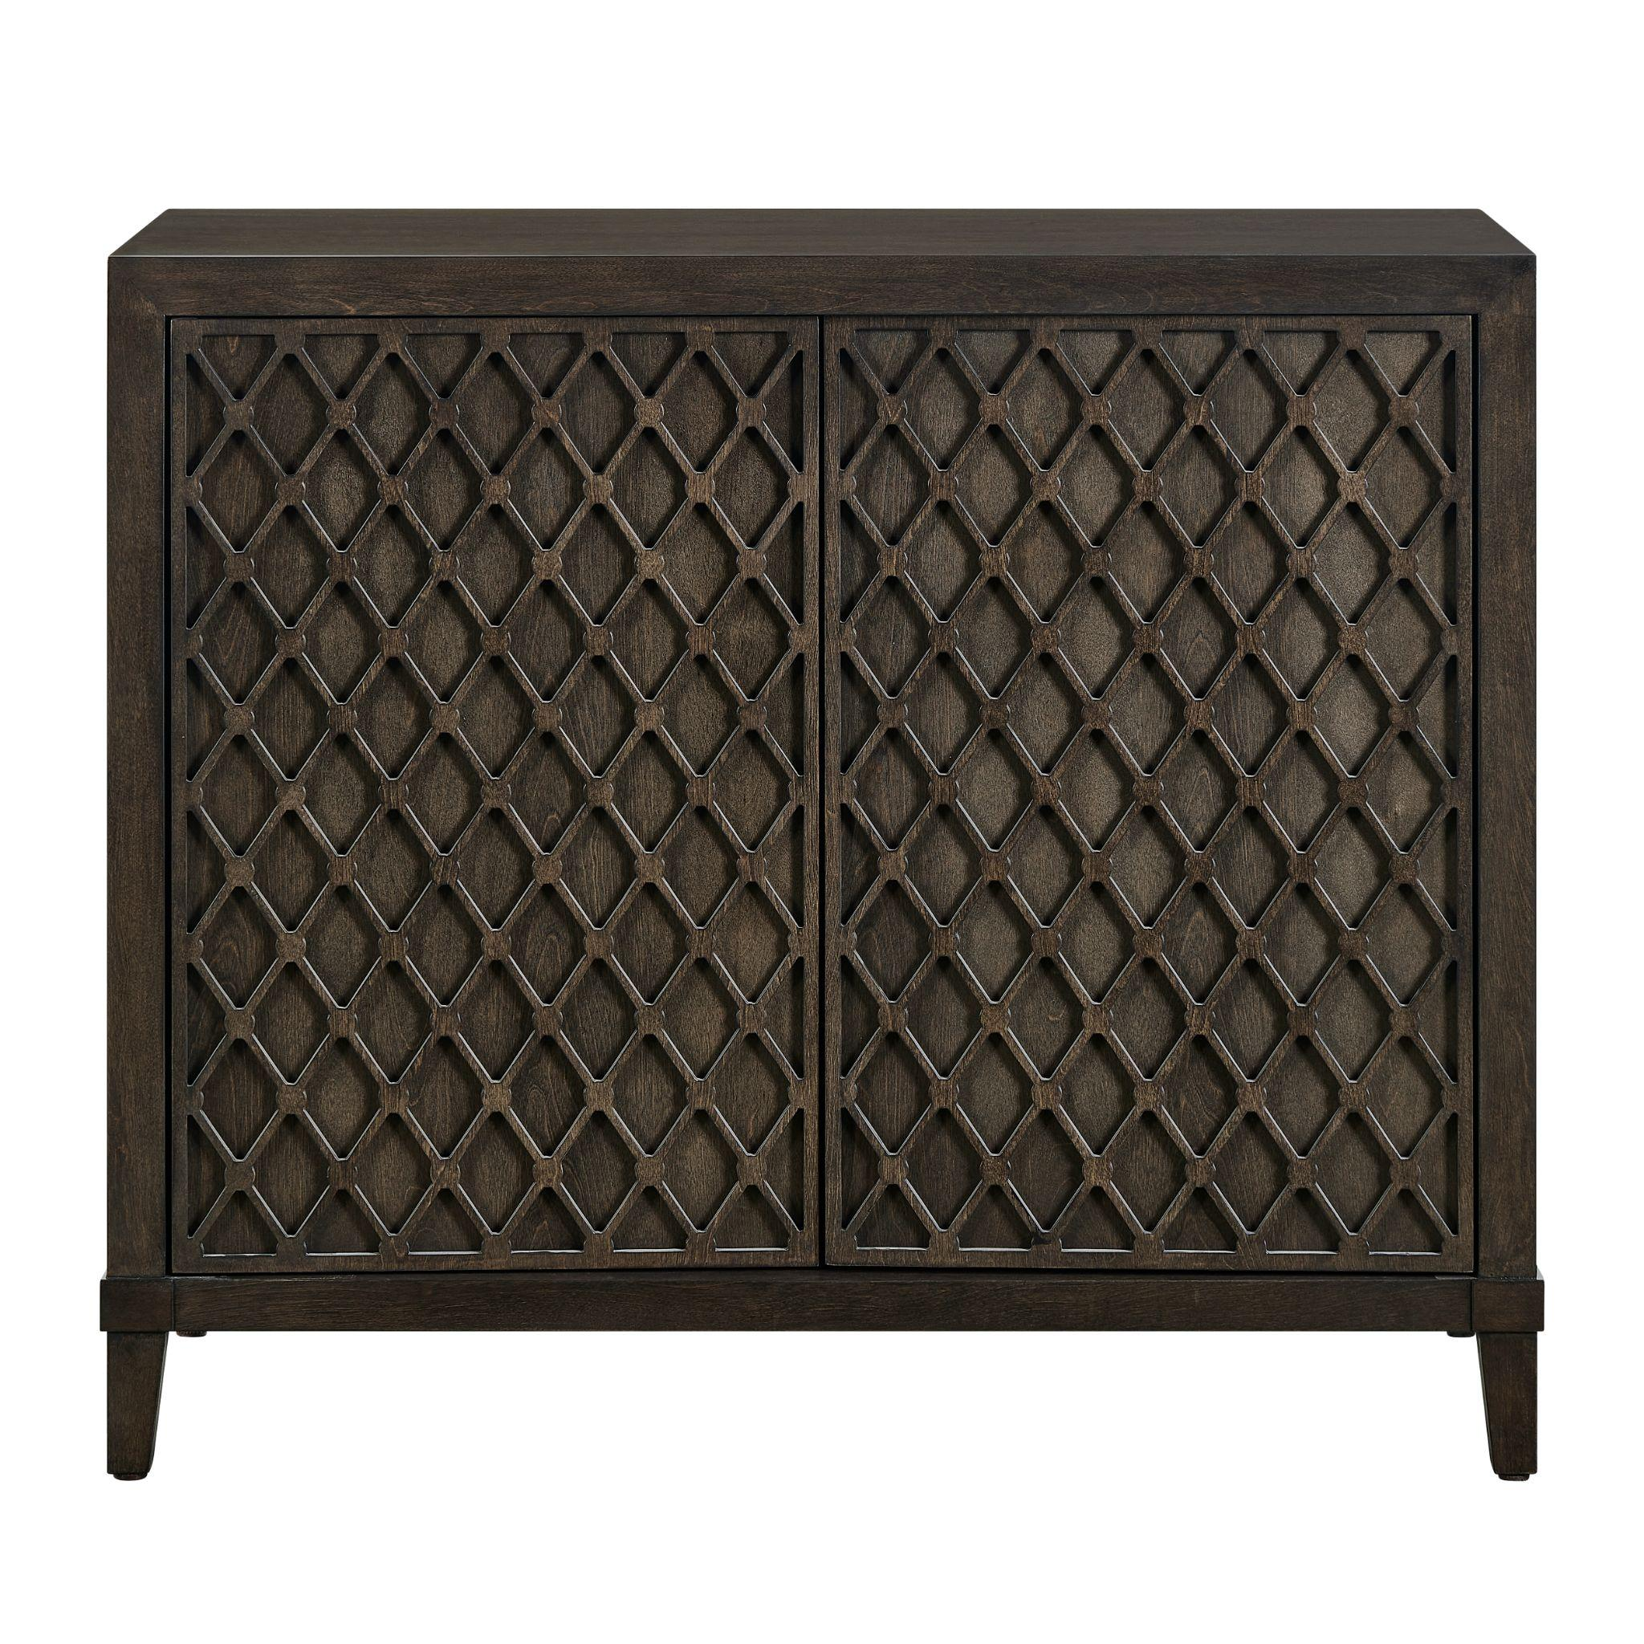

Fenwick Hall Chest
This petite, two-door chest on tapered legs steals the show with its door facades, detailed in tone-on-tone lattice work.

# # #

About Universal
Retailers and interior designers around the world trust Universal Furniture’s award-winning, smart and stylish designs to create modern, well-appointed living spaces for the whole home. The company’s casegood, upholstery, accent and outdoor designs are developed under the brand names Universal Furniture, Miranda Kerr Home and Coastal Living.

Universal Furniture, founded in 1968 and based in High Point, N.C., is the recipient of 14 Pinnacle awards for design excellence from the International Society of Furniture Designers. It is a brand of Samson Holdings, one of the world’s largest vertically integrated furniture manufacturers. For more information, please visit www.universalfurniture.com, or find us on Facebook, Instagram, and Pinterest @UniversalFurn.

