

FOR IMMEDIATE RELEASE SHOWROOM: 101 S. Hamilton

Contact: Mary Leigh Howell
ml@maryleighhowell.com
(336) 317-7713

Universal Furniture’s Velora Collection Captures the
Softer Side of Luxury with Modern Romantic Appeal

HIGH POINT, N.C., April 22, 2026 – Universal Furniture is leaning into the modern romantic era this market with the introduction of the Velora Collection. Defined by sculptural silhouettes, gentle curves and rich textural details, Velora feels both refined and approachable, offering a soft, glamorous expression of comfort and understated luxury.

Heavily influenced by European travels, Velora has a dreamy, almost transportive quality, expressed through light wood finishes and a palette that highlights the softer side of Universal Furniture’s collection business. A lightly wire-brushed oak in a pale taupe finish is complemented by Desert Gold, Stainless Steel and Antique Bronze accents, adding subtle contrast and depth. Honed Amalfi Cream marble brings a soft luminosity to case pieces while flared feet, rounded forms, bowed fronts and micro-reeding on drawer fronts introduce just the right amount of sophistication and detail.

“While Velora has elegant details and finishes, it still communicates a casual, transitional vibe,” said Sean O’Connor, president of Universal Furniture. “There is a great deal of versatility in this collection, which really speaks to how consumers and designers are furnishing their homes today. People are looking for pieces that feel elevated but still livable, and Velora strikes that balance. It can move easily between spaces and styles, bringing a sense of softness and sophistication without feeling overly formal.”

The Velora Collection includes more than 40 pieces, featuring versatile bedroom, dining and occasional furniture. [Images linked to product name] Some of the collection highlights include:

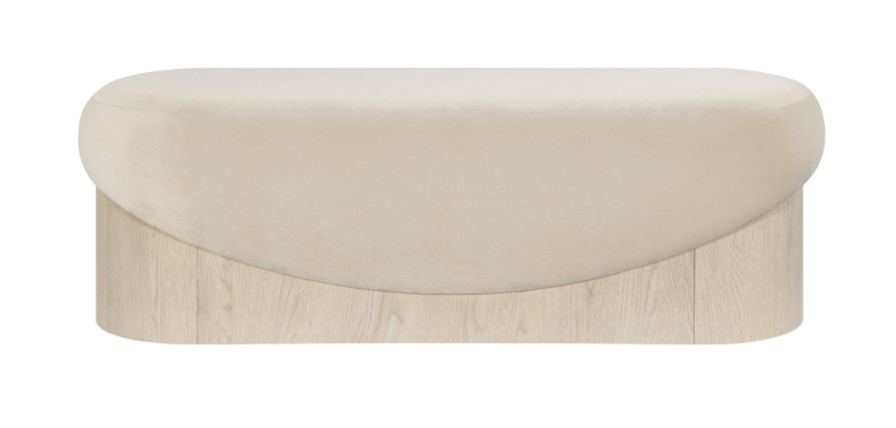

Velora Bench
Geometrical shapes with a lightly wire-brushed oak and upholstered velvet combine in the Velora Bench. The unique oval design contrasts a concave oak base with a convex, upholstered seat in creamy velvet.

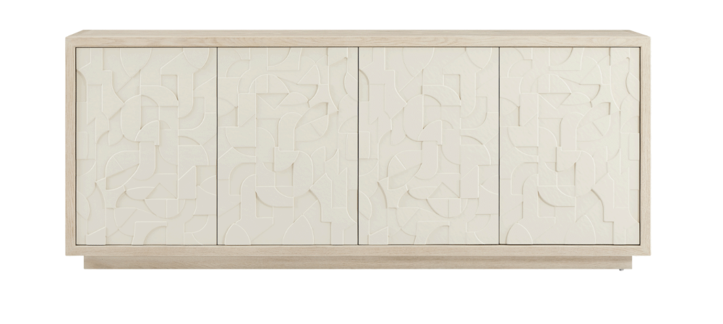
Velora Paloma Credenza
A true statement piece, the Velora Paloma Credenza features a lightly wire-brushed oak base for a spectacular artistic display on the doors. Soft, graphic shapes are cast in resin for a tone-on-tone effect.

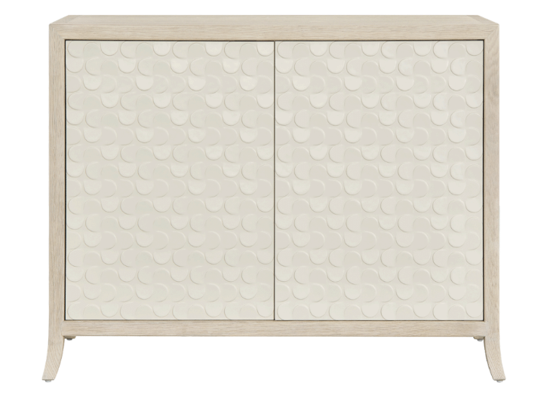

Velora Paloma Chest
Similar in design detail to the Credenza, the Velora Paloma Chest features a repeating circular motif cast in resin that creates a tone-on-tone effect with the creamy Velora wood finish. Slightly flared feet add a subtle hint of attitude.

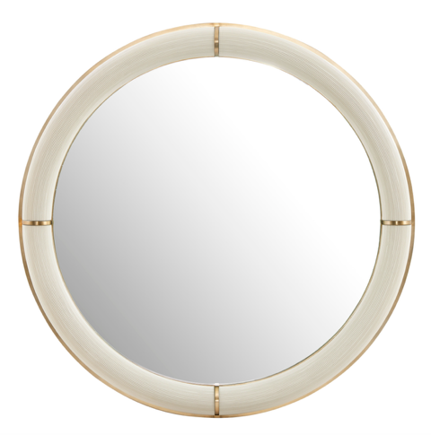

Velora Paloma Mirror
Round 44 inches in diameter, the Paloma mirror combines the collections wire brushed oak finish, dusty gold hardware and creamy white micro-reeding texture. At a distance, the mirror is symmetrical and elegant. As your approach it, the other layers of detail reveal themselves.

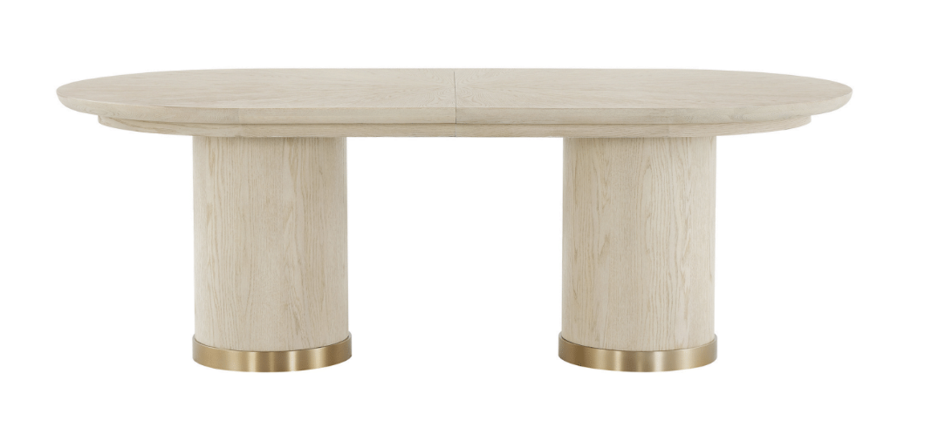

Velora Oval Dining Table
Double Pedestals trimmed in Desert Gold finish support the oval base of this table, all set in wire-brushed oak. The 86-inch table comes with two 18-inch leaves for the ultimate dinner party experience.

# # #

About Universal
Retailers and interior designers around the world trust Universal Furniture’s award-winning, smart and stylish designs to create modern, well-appointed living spaces for the whole home. The company’s casegood, upholstery, accent and outdoor designs are developed under the brand names Universal Furniture, Miranda Kerr Home and Coastal Living.

Universal Furniture, founded in 1968 and based in High Point, N.C., is the recipient of 14 Pinnacle awards for design excellence from the International Society of Furniture Designers. It is a brand of Samson Holdings, one of the world’s largest vertically integrated furniture manufacturers. For more information, please visit www.universalfurniture.com, or find us on Facebook, Instagram, and Pinterest @UniversalFurn.

