

FOR IMMEDIATE RELEASE SHOWROOM: 101 S. Hamilton

Contact: Mary Leigh Howell
ml@maryleighhowell.com
(336) 317-7713

A Clear Point of View: Universal Furniture Emphasizes Benchmade Upholstery Designs
HIGH POINT, N.C., April 22, 2026 – Universal Furniture’s Vice President of Upholstery, Rick Lovegrove, has a strong lineup in store for visitors to this April’s High Point Market. Drawing inspiration from his travels, ongoing research and the company’s new upholstery facility in Hildebran, North Carolina, Lovegrove is introducing a range of new designs spanning both the benchmade collection and in-stock offerings.
“With the opening of our new facility in Hildebran, we’re establishing a clear point of view for upholstery at Universal. It is benchmade in North Carolina and grounded in strong, foundational frames,” Lovegrove said. The Hildebran plant celebrated its grand opening on March 25.

“As for what’s shaping this spring’s introductions, we’re seeing a strong resurgence of what we call ‘heritage reimagined,’ or the new traditional influence. These are skirted silhouettes that feel tailored rather than fussy and are just as at home in a modern interior as they are in a century-old Victorian or brownstone.”

Benchmade
The new benchmade upholstery designs strike a balance between modern and new traditional style, elevated by rich fabrics and leathers that add depth and dimension. At the core of the collection is a consistent seating experience designed to deliver lasting support and comfort while withstanding everyday use.

Three foundational frames anchor the benchmade collection: Ryman, Madison and Henri. Each is available in a range of configurations and sizes to suit different spaces. The introductions also include seven new accent chairs, such as the Asher swivel chair, the Amira chair and two additions to Universal’s domestic motion offering: the Aston recliner and the Hudson petite recliner. Hudson has long been a customer favorite, as a sofa and a standard sized recliner.

A quintessential modern silhouette, Ryman features a six-inch track arm and a relaxed interior. Built in North Carolina, the style is available upholstered or slipcovered.

A modern interpretation of traditional design, Madison pairs a softly flared arm with a tailored skirt for a look that feels both familiar and refined. It is available in both skirted and upholstered versions.

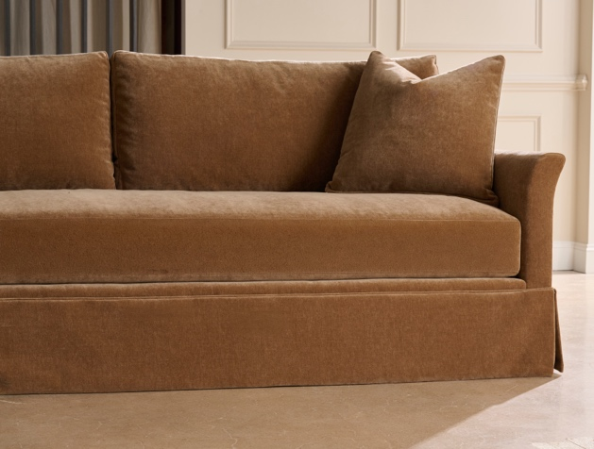
Henri is defined by its high back and gets its flair from delicately flared arms. Comfort comes from the loose seat and back cushion.

A refined club form, Asher features full-grain Italian leather, architectural lines and a smooth swivel base suited for modern living. The style is available in both fabric and leather, with options for tailored, skirted or slipcovered finishes. It can also be adapted for outdoor use.

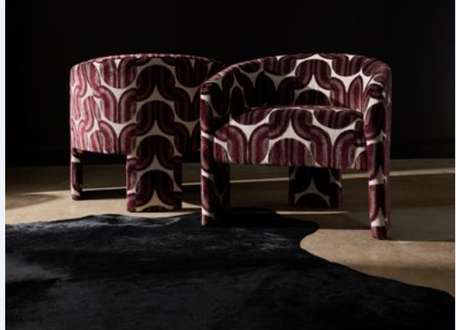

Amira is decidedly modern with a low, sloping barrel back and tight seat. Three wide, modern legs set off this piece, all fully upholstered for a seamless look.

“We are really excited about the launch of our washable slipcover collection, which is equally at home at the beach as it is in the city,” said Lovegrove. “It delivers an effortless aesthetic without sacrificing durability.” Fifty machine-washable fabrics will be available as part of the collection.

Stocked Program
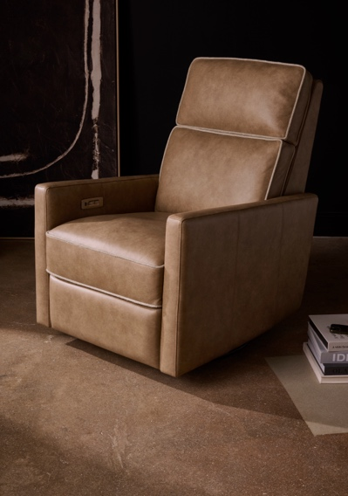
Universal’s stocked upholstery program gets a spring refresh as well. New motion styles include best-selling SKUs refreshed in new performance fabrics and leathers. The top-selling Fillmore suite has been reinterpreted as a power-motion sofa and chair, available in both leather and fabric options. The Vaught and Jaxon styles represent a new category within motion for Universal, stand-alone power, swivel-glide recliners.

Exuding tailored elegance, the Moore swivel is trimmed in beautiful wood trim that ties to the Velora and Fenwick finishes, dressed in a performance linen blend.

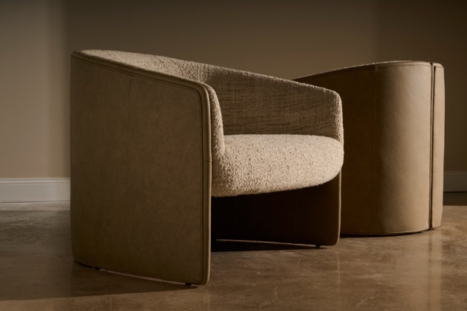
The Giorgi chair is a striking blend of sculptural form and material contrast, a softly curved, fully upholstered seat is complemented by the leather wrapped back and modern style.

The Augustine slipcovered collection is an effortless blend of relaxed comfort and tailored simplicity. Slipcovered in a washable, family-friendly performance fabric, Augustine works in urban and coastal areas. The style is available in two sofa sizes, a swivel glider and a queen sleeper.

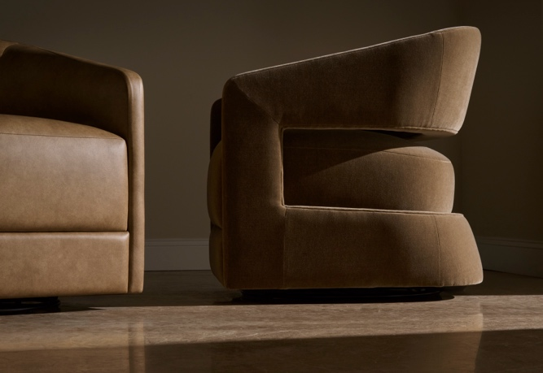
The Drew swivel chair features a sculptural form, with clean lines and modern style, upholstered three ways in linen, velvet and leather.
Rounding out the stocked program is the Miles modular collection, a tailored track-arm design featuring feather-filled lumbar pillows. With five available SKUs, Miles can be built into a large modular sectional or scaled down to a two-piece sofa, while a coordinating storage ottoman provides both a comfortable footrest and functional storage.

# # #
About Universal
Retailers and interior designers around the world trust Universal Furniture’s award-winning, smart and stylish designs to create modern, well-appointed living spaces for the whole home. The company’s casegood, upholstery, accent and outdoor designs are developed under the brand names Universal Furniture, Miranda Kerr Home and Coastal Living.

Universal Furniture, founded in 1968 and based in High Point, N.C., is the recipient of 14 Pinnacle awards for design excellence from the International Society of Furniture Designers. It is a brand of Samson Holdings, one of the world’s largest vertically integrated furniture manufacturers. For more information, please visit www.universalfurniture.com, or find us on Facebook, Instagram, and Pinterest @UniversalFurn.

