Trends in Contemporary Design Seen at 220 Elm
JUNE 20, 2015 BY: JEANNECOMMENT
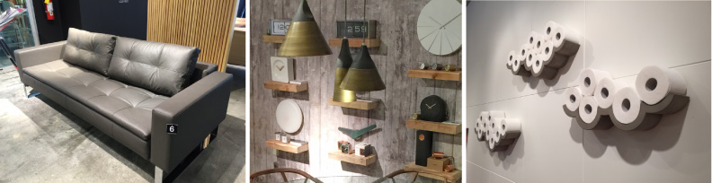
I have been attending High Point Market for the past few seasons— two of the seasons as an official High Point Market Style Spotter and this past April for the first time attending as a sponsored blogger for 220 Elm. 220 Elm is known as the place to go for contemporary design from around the world and is situated in downtown High Point in the heart of all the action. Exhibitors in 220 Elm come from around the world, including Italy, Holland, Finland, Germany, and North America.
Because I frequent many trade shows throughout the year, I have the opportunity to see many design trends as they emerge. There was no shortage of trends seen during market at 220 Elm, and because many of the lines represented in the building are based in Europe, the trends I saw were comparable to what I would see in the showrooms that cater to contemporary design in the larger, more cosmopolitan cities around the country such as New York or Los Angeles.

Trends in Contemporary Design at 220 Elm
Some of the trends spotted at 220 Elm this past April included:
•Mixed Metals
•Concrete
•Furniture designed for smaller spaces
•Integration of Electronic Devices into Furniture
•Emphasis on the Wood Grain

Mixed Metals
Brass started coming back en vogue again roughly about three years ago, after a three decade hiatus. Since then we have been seeing a huge resurgence in all metal finishes – pewter, brass, bronze, rose gold, copper. While brass has been well represented at High Point Market for the past few seasons, I am finally starting to see more variety in metal finishes, but mainly in the more contemporary showrooms found in 220 Elm. Below are the tube clock and speaker that is available in several metal finishes from Dutch based manufacturer Leff Amsterdam.
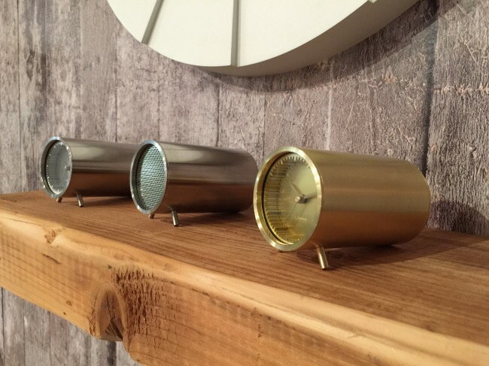
Leff Amsterdam at Leif Petersen
More “mixed metal finds” seen at the Leif Petersen showroom. Another trend in contemporary design seen in the photo below— mixed media, where metal is mixed with wood, porcelain, and other materials.
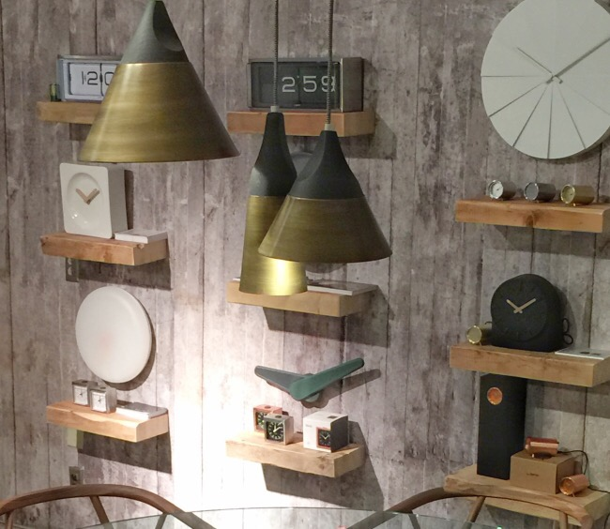
Leff Amsterdam at Leif Petersen

Concrete
Concrete products have been used in the construction of homes for a number of reasons including less energy required for heating and cooling, durability, fire and rot resistance. But only recently have poured concrete surface applications and furniture taken off and are currently seeing an increased demand in the marketplace.
French manufacturer Lyon Beton showcased a variety of freestanding concrete pieces for the home. Monobloc concrete storage cubes are assembled to form a cocktail table, with the ability to create different shapes tailored specifically to the needs of the homeowner.
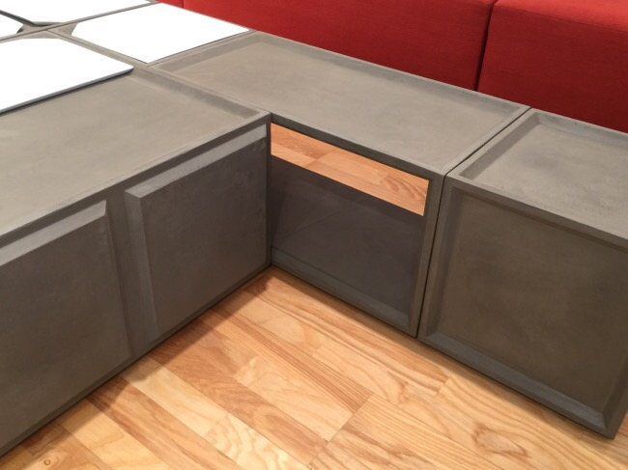
Lyon Beton
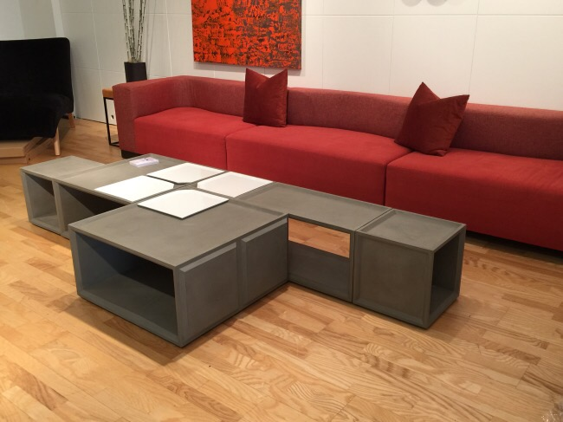
Lyon Beton
Instead of being configured horizontally, the Monobloc storage cubes can also be configured vertically to create shelving. A versatile and cleverly designed piece, the possibilities are limited only by one’s imagination.
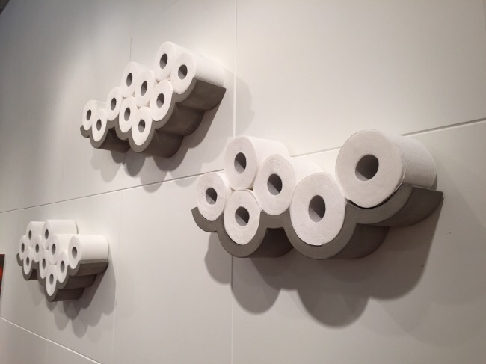
Lyon Beton
Above, a chic little spot to store toilet paper on the wall – utilitarian turned chic.
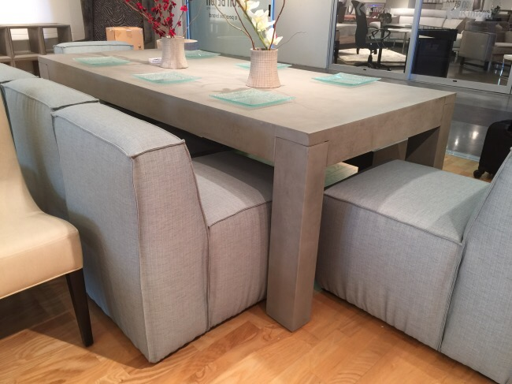
Lyon Beton
A cast concrete dining table, above and bistro set, below is suitable for indoor/outdoor use.
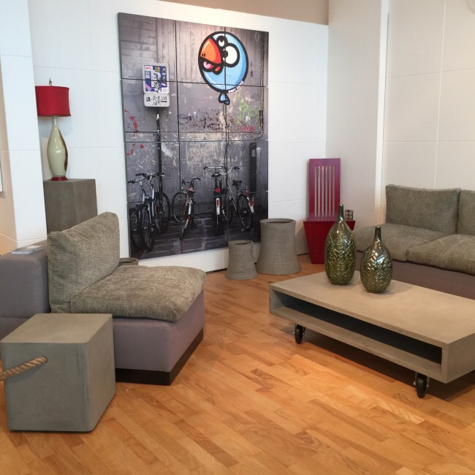
Lyon Beton
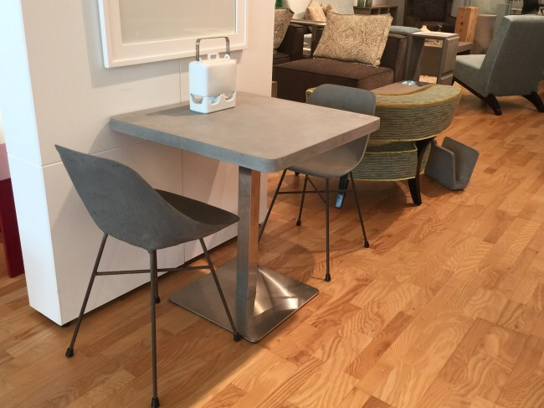
Lyon Beton

Furniture that Caters to Smaller Spaces
With urbanization on the rise, so is the need for furniture that will accommodate these smaller spaces. A guest room may not always be an option in every household, and this is when the homeowner turns to convertible furniture. Long gone are the sofa beds that are big and bulky with springs that stick into your side as you sleep. This mattress fromInnovation is cleverly concealed and a breeze to open.
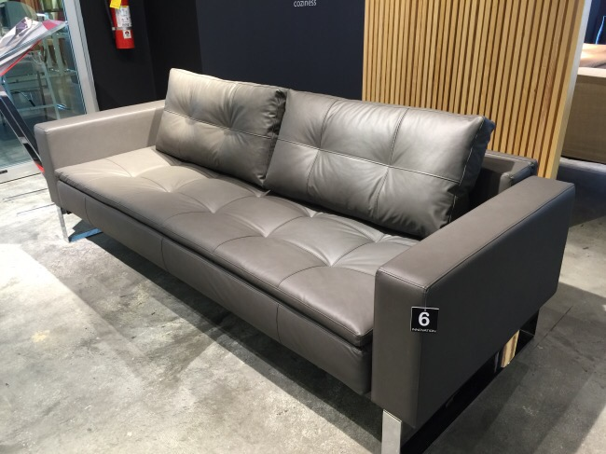
Innovation
Rather than the mattress being hidden within the sofa frame, it cleverly folds and is stored on the back of the sofa when not in use.
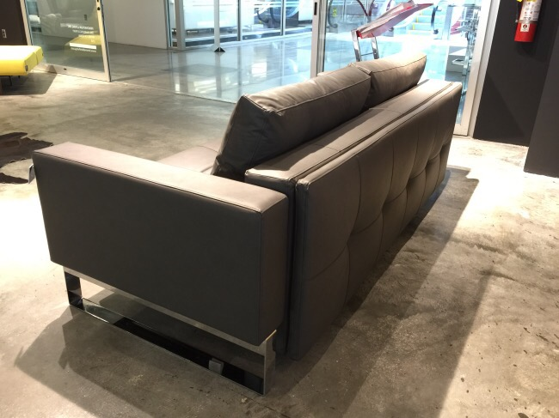
Innovation

Palliser’s sofa bed is accessible without having to remove any cushions, leaving the area around the sofa bed clutter-free when the bed is in use. A memory foam mattress also makes for a restful night.

Addicted to Our Electronic Devices
I am amazed at how many seating choices cater to our need to be constantly attached to our electronic devices. Canadian manufacturer Palliser lead the way with theater seating offering USB outlets within the inner armrest to charge devices and a stand to hold a tablet in a comfortable, hands-free reading position. A flexible goose neck lamp attached to the armrests provides extra light when needed.
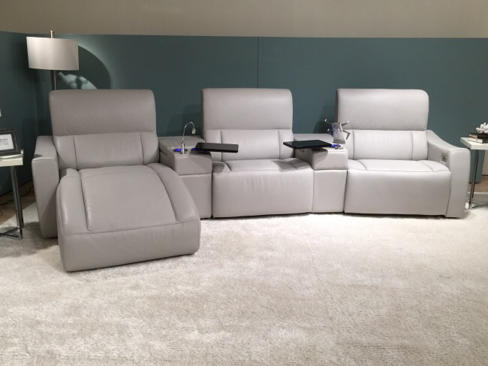
Palliser
Blue-lit cupholders give off a modern, almost futuristic appeal.
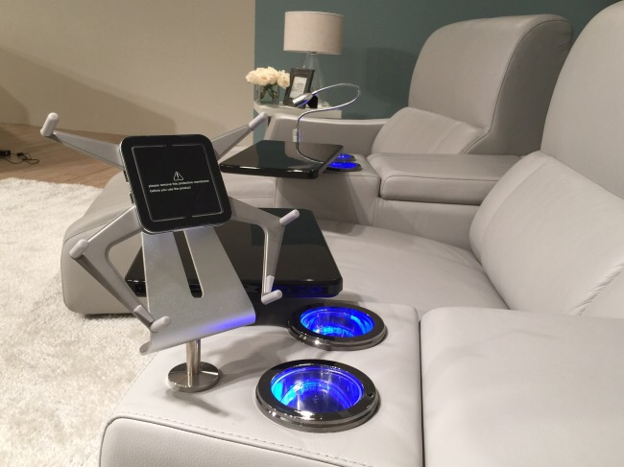
Palliser
Ample storage beneath the armrests, similar to what one would find between the center console in a larger car, acts as a divider between seats. My suggestion to the person showing me around was to make this storage refrigerated, which would give you reason to never leave your seat!
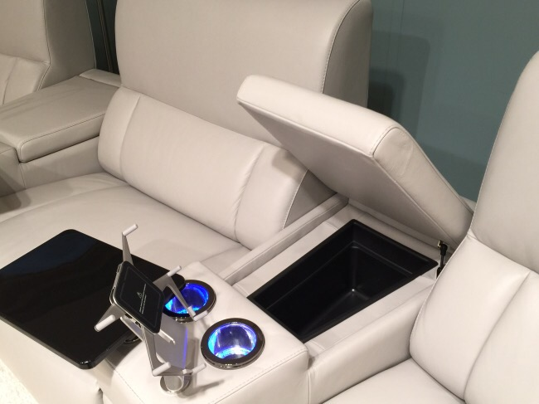
Palliser
Brazilian upholstery manufacturer Lafer, offers a recliner with an optional lamp and work station, which is perfect for working on a laptop or tablet.
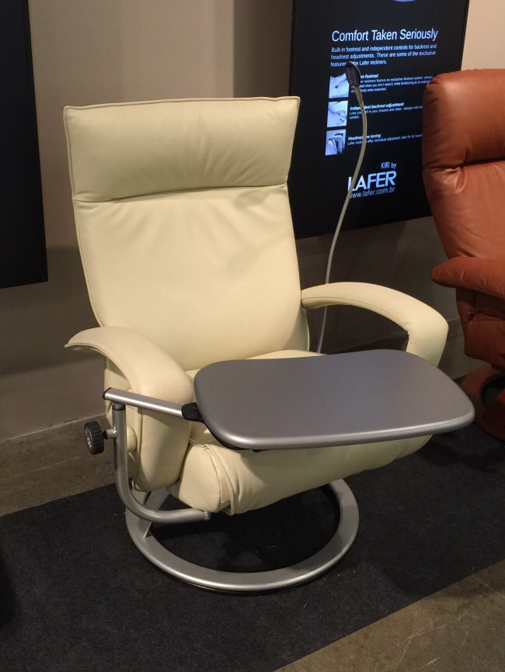
Lafer at Leif Petersen

Emphasis on the Wood Grain
Cerused finishes and finishes that highlight the natural striations in the wood grain is a trend that I have been seeing in every sector of the home furnishings market, and in all price points. Below is a selection from Casana‘s Casablanca Collection.
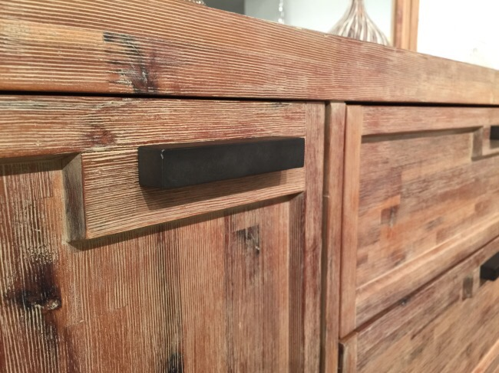
Casana
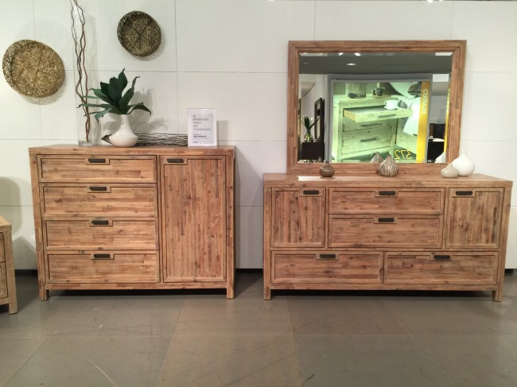
Casana
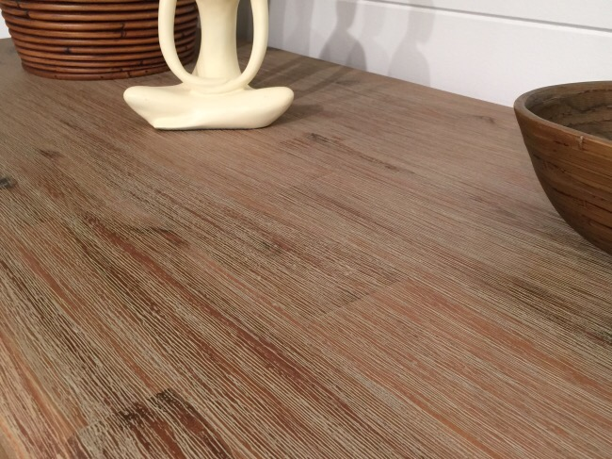
Casana
A huge thank you to Heinz Kattenfeld, COO for 220 Elm for hosting me for lunch and 220 Elm for sponsoring my trip to High Point Market. It is always a pleasure to visit the building and even better when I find new resources, like I did on this trip. Thanks again!


