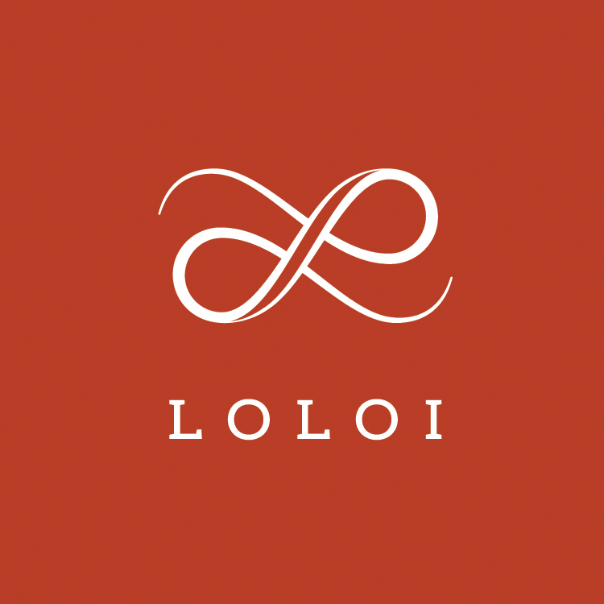
Media Contact:
Jennifer Green
jgreen@burns360.com
214-521-8596 x103

Loloi Hosts Design Tour with Justina Blakeney at High Point
Event to offer preview of new rug and pillow collections

DALLAS (March 23, 2018) — Loloi announces it will host a meet-n-greet and design tour event with renowned designer and author, Justina Blakeney during the Spring High Point Market. Taking place on Saturday, April 14 from 1:30-3:30 p.m. in Loloi’s showroom, IHFC D320, the event will offer customers a chance to visit with Blakeney, hear about her design inspiration and process and preview her new rug and pillow collections with Loloi.

As one of Loloi’s licensed collaborations, the Justina Blakeney x Loloi collection will debut three new rug collections and various new pillow designs. The new additions will carry Blakeney’s signature bohemian-inspired aesthetic, while also incorporating some more traditional motifs.

New Justina Blakeney introductions for the Spring High Point Market include:
Cielo
Featuring time-honored motifs in a color-rich palette, the Cielo Collection is durable series that’s printed in Turkey of 100% polyester. Designed by Justina Blakeney for Loloi.

Silvia
Power-loomed in Turkey of 100% polypropylene, the Silvia Collection transforms interiors with rich, jewel-toned hues, accentuated by a ribbed texture that feels remarkably soft underfoot. Even better, the pile doesn’t shed, and is exceptionally durable—perfect for the busiest rooms. Designed by Justina Blakeney for Loloi.

Cornelia
Soft, durable and textured, the Cornelia Collection features a ribbed texture and generous fringe that lends a casual, yet up-to-date aesthetic. Cornelia is printed in India of jute and chenille, ensuring a comfortable feel underfoot. Designed by Justina Blakeney for Loloi.

For news, decorating guidelines and other updates from Loloi, connect via Facebook, Instagram, or online at LoloiRugs.com.

About LOLOI RUGS
Founded in 2004, LOLOI has become a fashion leader specializing in medium- to high-end area rugs in every style category, and a premium producer of textiles. Under the expert direction of area rug veteran Amir Loloi, the company has been inducted into the ARTS Awards Hall of Fame, winning five ARTS Awards for “Best Rug Manufacturer” in 2010, 2011, 2015, 2016 and 2017, one in 2012 for "Best Outdoor Manufacturer," and one in 2013 for “Green Manufacturer.” Its eight America’s Magnificent Carpets Awards and three Atlanta Visual Display Awards for sophisticated showroom design attest to the company’s commitment to innovation and quality.

LOLOI RUGS is headquartered in Dallas, with to-the-trade showrooms at: 295 Fifth Ave., New York, Showroom #1006 ● DallasMarketCenter, Suite 506 ● Las Vegas Market, Building B, Suite #480 ● High Point, IHFC Showroom #D-320 ● and AmericasMart, Atlanta, Showroom #4-D-2. For more information, visit: www.loloirugs.com. Call: (866) 362-1424.
###

