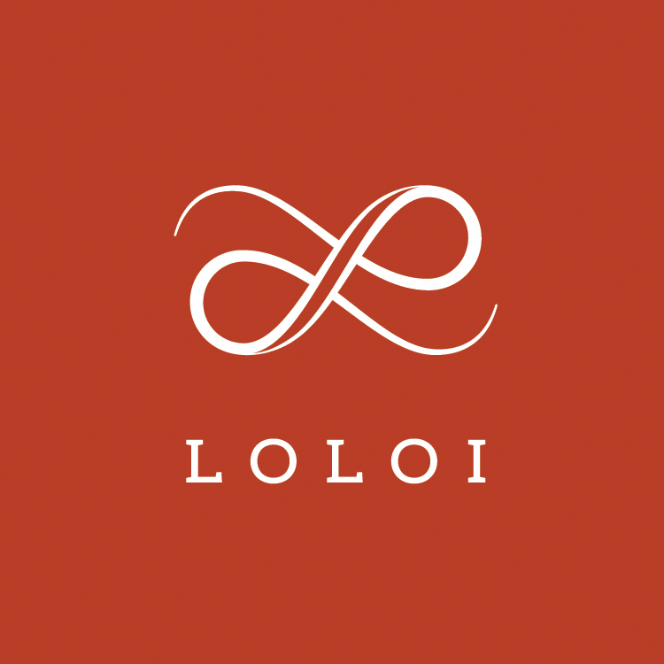
FOR IMMEDIATE RELEASE
CONTACT:
Jennifer Green
jgreen@burns-360
214-521-8596 x103

Loloi to Showcase New Magnolia Home by Joanna Gaines Designs in High Point
Dallas-based manufacturer will unveil rugs, throws, and pillows at upcoming spring Market

DALLAS (March 28, 2018) — Loloi, a fashion leader specializing in medium-to high-end area rugs in every style category, and a premium producer of textiles, will introduce new rug collections, along with an assortment of new pillow and throw designs for its popular Magnolia Home by Joanna Gaines line during the spring High Point Market on April 14-18.

Crafted by Loloi in varying styles and materials, additions to the Magnolia Home by Joanna Gaines rug collections include:

Elliston
Textured and tonal, the Elliston Collection for Magnolia Home by Joanna Gaines is a versatile rug for any space. These timeless pieces are hand-woven by artisans in India of wool and polyester, ensuring long-lasting durability and refined subtleties.

Evie
Power-loomed of 100% polypropylene in Egypt, the Evie Collection for Magnolia Home by Joanna Gaines features traditional designs, completely reimagined for today’s interiors. These durable pieces are designed to withstand foot-traffic in any space, and will retain color for years.

Kasuri
Our fresh take on traditional East Indian fabrics. Colorful and patterned, the Kasuri Collection for Magnolia Home by Joanna Gaines is made of 100% wool, hooked by skilled artisans in India. Even better, each piece is embellished with 4” tonal braided tassels for a relaxed, but detailed finish.

In addition to an assortment of new pillow and throw designs, Loloi will also be adding to the existing Lucca and Lotus collections of the Magnolia Home by Joanna Gaines line, offering additional colorways and design motifs.

All of these exclusive new products will showcase at the upcoming spring High Point Market in Loloi’s showroom, IHFC Design Center, Space 320.

For news, decorating guidelines and other updates from Loloi, connect via Facebook, Instagram, or online at LoloiRugs.com.

About LOLOI RUGS
Founded in 2004, LOLOI has become a fashion leader specializing in medium- to high-end area rugs in every style category, and a premium producer of textiles. Under the expert direction of area rug veteran Amir Loloi, the company has been inducted into the ARTS Awards Hall of Fame, winning five ARTS Awards for “Best Rug Manufacturer” in 2010, 2011, 2015, 2016 and 2017, one in 2012 for "Best Outdoor Manufacturer," and one in 2013 for “Green Manufacturer.” Its eight America’s Magnificent Carpets Awards and three Atlanta Visual Display Awards for sophisticated showroom design attest to the company’s commitment to innovation and quality. LOLOI RUGS is headquartered in Dallas, with to-the-trade showrooms at: 295 Fifth Ave., New York, Showroom #1006 ● DallasMarketCenter, Suite 506 ● Las Vegas Market, Building B, Suite #480 ● High Point, IHFC Showroom #D-320 ● and AmericasMart, Atlanta, Showroom #4-D-2. For more information, visit: www.loloirugs.com. Call: (866) 362-1424.

