FOR IMMEDIATE RELEASE

CONTACT:
Jennifer Green
jgreen@mbapr.com
214-521-8596

Loloi to Debut 50 New Pillows at High Point Market
Updated tones, textures, traditions among the themes introduced

DALLAS (March 24, 2014) ― Loloi is set to debut 50 fun, festive and fashionable pillows during the Spring High Point Market in Loloi’s showroom, IHFC #D-320. As the newest designs in Loloi’s growing collection, these pillows range from classic to contemporary to extremely colorful.
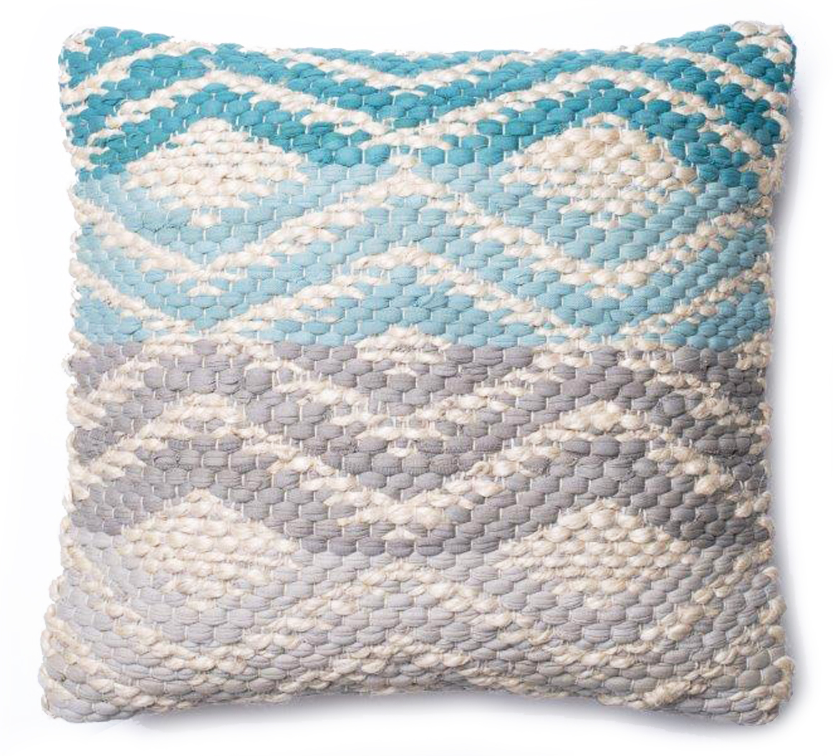
The new collection will incorporate:
Tones- Tones are the new neutrals that fit into almost any environment. Taupe, gray, black and white are mixed and matched in a sleek contemporary design.
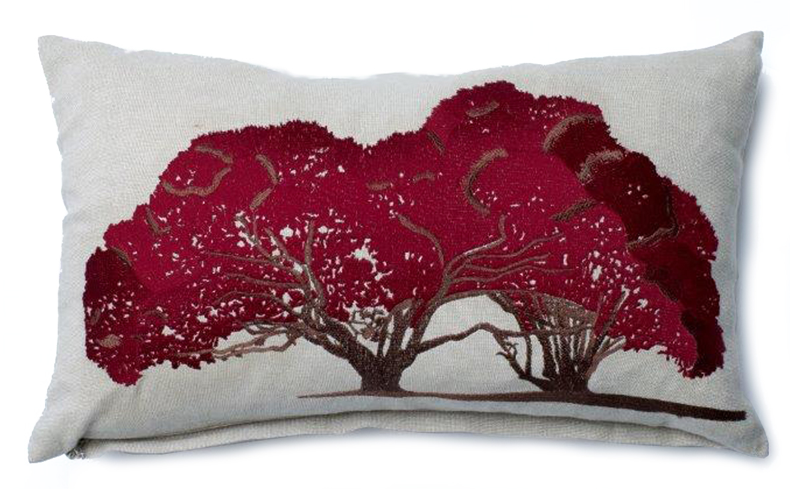
Textures- Chunky textures such as weaves, braids and ultra shags are featured in friendly palettes like teal and taupe or coral and gray.
Softness- This collection of linen and velvet textiles features fresh, relaxed sensibility and soft, subtle tones of light gray and taupe with hints of lavender and silver.
New Traditions- Loloi pairs traditional color palettes with modern designs while keeping contemporary base colors such as taupe and gray.
“Bringing fashion-forward home furnishing accessories to our customers and vendors has been our focus for the past decade,” said Amir Loloi, CEO of Loloi. “Just seeing the popularity of our pillow line tells us there is demand for our fresh and unique designs. With a range of colors, textures and styles to choose from, we’re able to provide the perfect look for every room in any home. This collection definitely keeps that trend going.”
Market attendees and members of the media are invited to Loloi’s 10th anniversary party on Sunday, Apr. 6 at 5 p.m. in Loloi’s showroom. Guests will be treated to a full bar, hors d'oeuvres and live music by Jaxon Jill, in honor of the company’s 10 years of success.

About LOLOI RUGS

Founded in 2004, LOLOI has become a fashion leader specializing in medium- to high-end area rugs in every style category, and a premium producer of textiles. Under the expert direction of area rug veteran Amir Loloi, the company has won two consecutive ARTS Awards for “Best Rug Manufacturer” in 2010 and 2011, one in 2012 for "Best Outdoor Manufacturer," and one in 2013 for “Green Manufacturer.” Its eight America’s Magnificent Carpets Awards and three Atlanta Visual Display Awards for sophisticated showroom design attest to the company’s commitment to innovation and quality.

LOLOI RUGS is headquartered in Dallas, with to-the-trade showrooms at: 295 Fifth Ave., New York, Showroom #1006 ● DallasMarketCenter, Suite #500 ● Las Vegas Market, Building B, Suite #480 ● High Point, IHFC Showroom #D-320 ● and AmericasMart, Atlanta, Showroom #4-D-2. For more information, visit: www.loloirugs.com. Call: (866) 362-1424.

