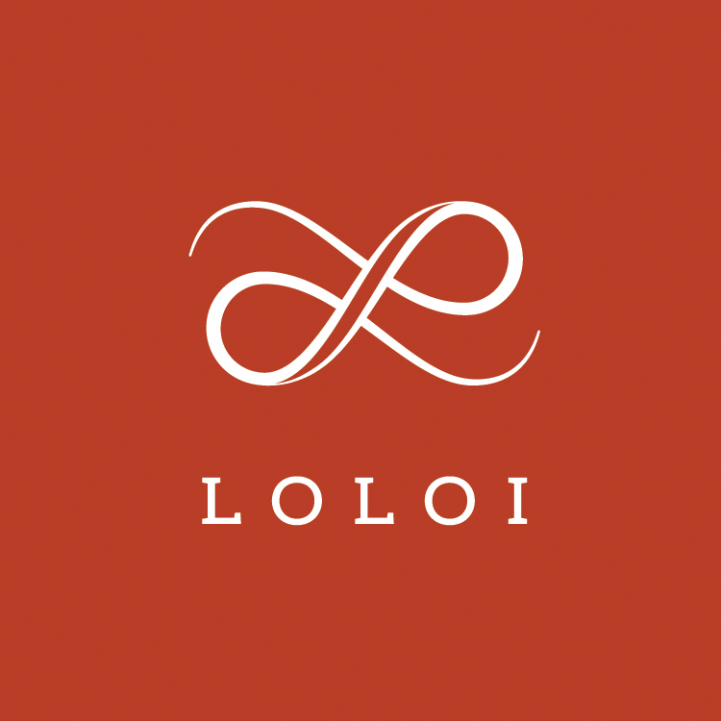
FOR IMMEDIATE RELEASE

CONTACT:
Jennifer Green
jgreen@burns-360.com
214-521-8596

Loloi Rugs Expands High Point Market Showroom

Textiles Leader Almost Doubles Total Space to 30,000 sq. ft.,
Elevates Brand Experience for Showroom Visitors

DALLAS (Feb. 28, 2019) ― Loloi Rugs is nearly doubling the space of its High Point Market showroom, the company announced today. Loloi will now take up 30,000 sq. ft. at IHFC Showroom #D-320, an increase of 12,000 sq. ft.

According to Amir Loloi, CEO, the expansion included the large hallway behind the company’s showroom, as well as three existing showroom spaces.
"Our growth has been extraordinary, and this showroom expansion is an opportunity to not only add some very needed space for our growing collections, but to also elevate the brand experience for showroom visitors," said Loloi.
The larger showroom will allow for better merchandising of Loloi's products, while providing a smoother and more comfortable traffic flow and overall customer experience.
The additional space will also allow for larger rug displays for all branded and licensed collections, including Magnolia Home by Joanna Gaines, ED Ellen DeGeneres, Rifle Paper Co. and Justina Blakeney.
"Our showroom will now present a dynamically different experience for our High Point visitors, and it's another exciting initiative we are doing to mark our 15th anniversary year," Loloi added.
About LOLOI RUGS
Founded in 2004, LOLOI has become a fashion leader specializing in medium- to high-end area rugs in every style category, and a premium producer of textiles. Under the expert direction of area rug veteran Amir Loloi, the company has been inducted into the ARTS Awards Hall of Fame, winning five ARTS Awards for “Best Rug Manufacturer” in 2010, 2011, 2015, 2016 and 2017, one in 2012 for "Best Outdoor Manufacturer," and one in 2013 for “Green Manufacturer.” Its eight America’s Magnificent Carpets Awards and three Atlanta Visual Display Awards for sophisticated showroom design attest to the company’s commitment to innovation and quality.
LOLOI RUGS is headquartered in Dallas, with to-the-trade showrooms at: 295 Fifth Ave., New York, Showroom #1006 ● DallasMarketCenter, Suite 506 ● Las Vegas Market, Building B, Suite #480 ● High Point, IHFC Showroom #D-320 ● and AmericasMart, Atlanta, Showroom #4-D-2. For more information, visit: www.loloirugs.com. Call: (866) 362-1424.

