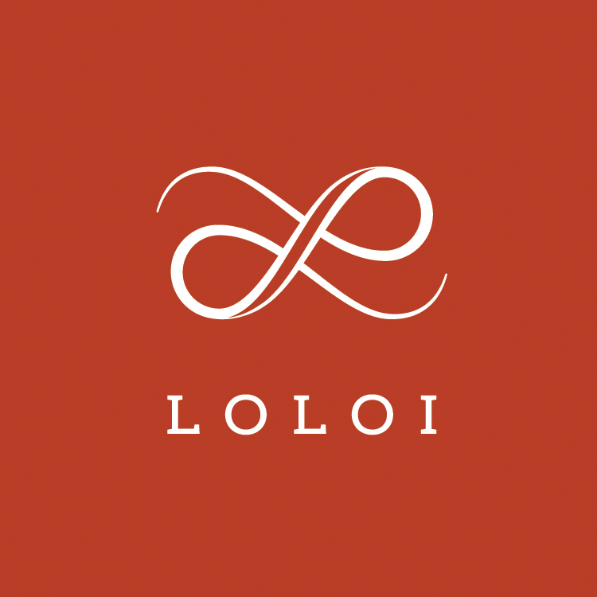
FOR IMMEDIATE RELEASE

CONTACT:
Jennifer Green
jgreen@burns-360.com
214-521-8596

LOLOI LAUNCHES NEW AND IMPROVED SITE
New features include faster search, better checkout flow, product video, complete order history, and one-of-a-kinds.
DALLAS — March 19, 2019 — Premiere rug and textile leader Loloi is announcing the launch of its new website (loloirugs.com). According to Cyrus Loloi, Principal of Loloi Rugs, the new site is fueled by customer feedback the company received over a year ago, leading Loloi to create a better, faster experience that serves customer needs. Loloi claims improved search, ease of ordering, order history, and overall user interface—especially on mobile—were the primary focus of the redesign.
“While trade shows remain an important way to engage with customers and show new products, we know that customers are browsing and ordering before and after shows as well. We think of the new site as a go-to resource for Loloi dealers the majority of the year we’re not at market,” adds Loloi.
The site will also include such enhancements as:
- Increased number of product images, as well as product video demonstrating the details of certain collections.
- Complete access to all Loloi rugs, pillows, and throws.
- Faster filters to make browsing seamless.
- One-of-a-kind rugs, which previously were not shown online.
- Real-time order information for dealers, including shipment tracking and invoices.
Featured on the new site will also be exclusive landing pages dedicated to Loloi’s collaborations with Magnolia Home by Joanna Gaines, ED Ellen DeGeneres, Justina Blakeney and the new Rifle Paper Co. x Loloi collection.
As always, Loloi will offer its dealers an array of free resources, such as its 2019 Loloi Catalog and Rugs 101 guide, which allow them to stay ahead of the curve and offer their consumers unparalleled expertise and know-how.
Trade professionals interested in creating an account to shop online can visit Loloi’s Become a Dealer page.

More about Loloi Rugs: Founded in 2004, Loloi has become a fashion leader specializing in medium- to high-end area rugs in every style category, and a premium producer of textiles. Under the expert direction of area rug veteran Amir Loloi, the company has been inducted into the ARTS Awards Hall of Fame, winning five ARTS Awards for “Best Rug Manufacturer” in 2010, 2011, 2015, 2016 and 2017, one in 2012 for "Best Outdoor Manufacturer," and one in 2013 for “Green Manufacturer.” Its eight America’s Magnificent Carpets Awards and three Atlanta Visual Display Awards for sophisticated showroom design attest to the company’s commitment to innovation and quality.
Loloi RUGS is headquartered in Dallas, with to-the-trade showrooms at: 295 Fifth Ave., New York, Showroom #1006 ● DallasMarketCenter, Suite 506 ● Las Vegas Market, Building B, Suite #480 ● High Point, IHFC Showroom #D-320 ● and AmericasMart, Atlanta, Showroom #4-D-2. For more information, visit: www.Loloirugs.com. Call: (866) 362-1424.

