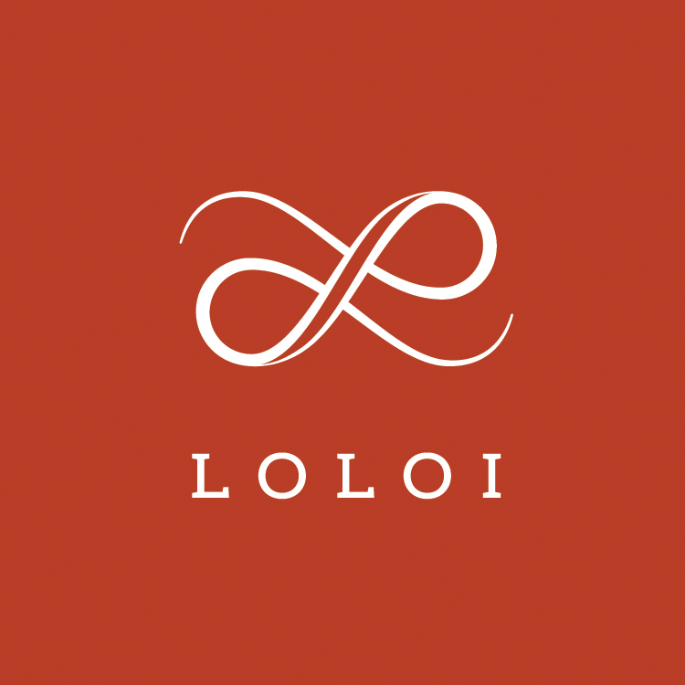
FOR IMMEDIATE RELEASE

CONTACT:
Jennifer Green
jgreen@burns-360.com
214-521-8596

Loloi Launches Wall Art Line at High Point Market

DALLAS (April 2, 2019) ― Loloi announces it has added a new product category to its extensive offering. Debuting more than 140 pieces at the Spring High Point Market, the premium textile producer will unveil its new line of wall art that includes one-of-a-kind pieces.
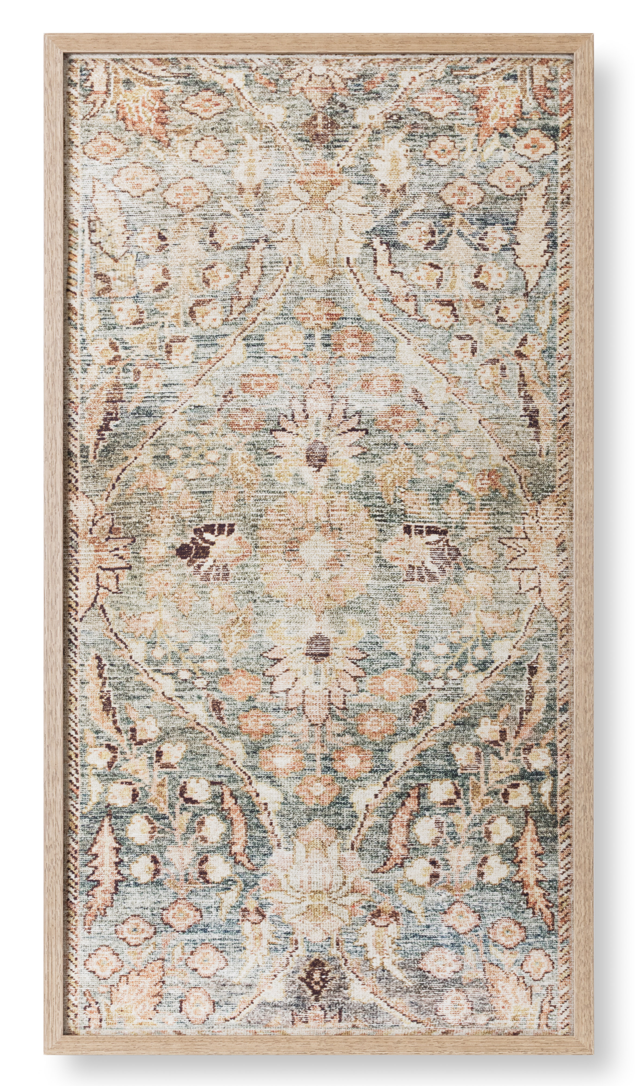
Staying true to Loloi’s core competency, the art is textile-driven, and will offer a fresh approach to this established category. The wall art pieces are assembled and framed at Loloi's Dallas headquarters by a specialized team of artists, and feature a variety of construction techniques including stitched fabrics, embroidery, fabrics on pins, woven yarns, textile collages, felted wool, woven mud cloths and more.

Wall art sizes will range from 7’’ x 12’’ to 54’’ x 44’’, and will come in a variety of frame types, including wood frames and shadow box acrylic. One-of-a-kind pieces will range from small to large as well and will be available for purchase at the upcoming High Point Market in Loloi’s newly expanded showroom.

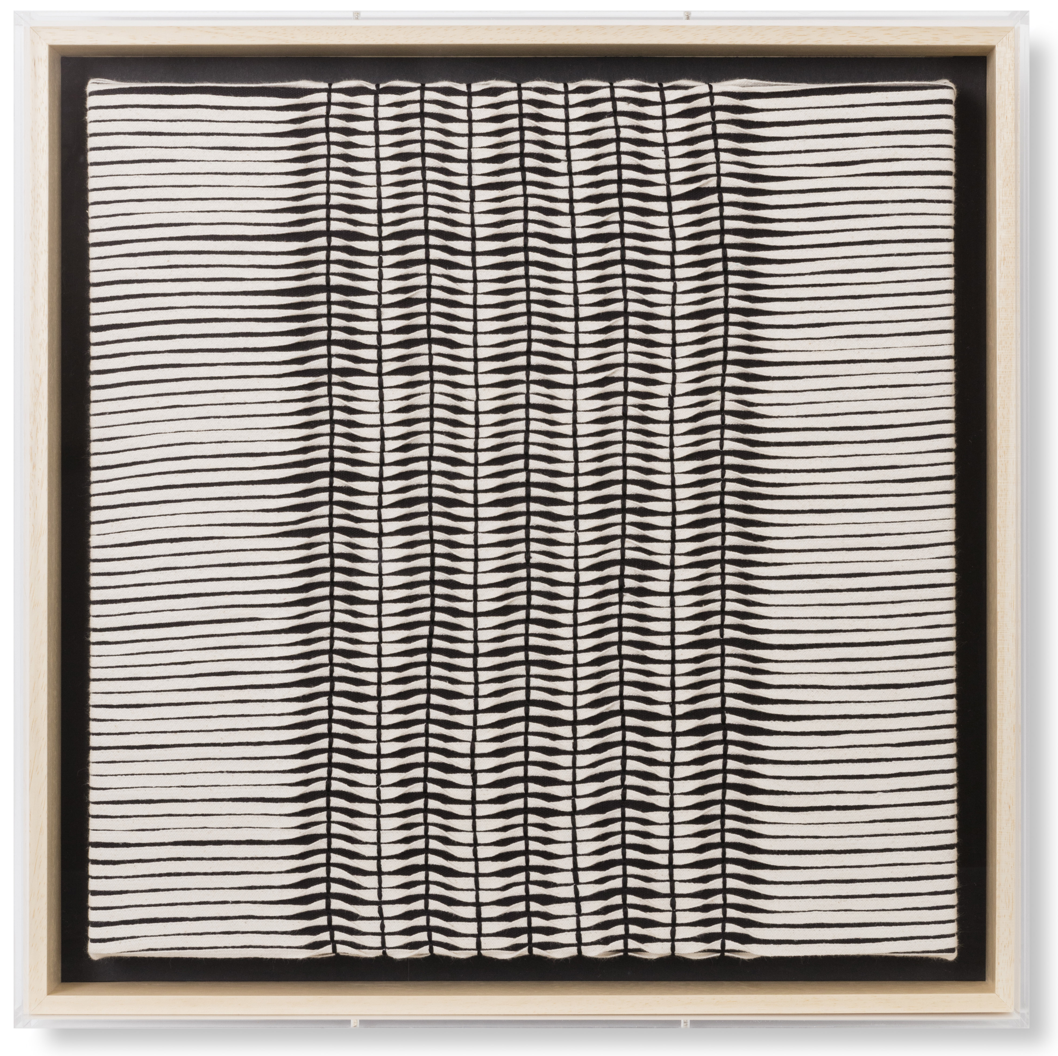
“From the beginning, our goal was to bring a fresh take on the established wall art category," said Amir Loloi, founder. "We believe with our expertise in textile design, these pieces are a natural extension of what we do well. Buyers can expect a program that’s both beautiful and different from anything else out there. We can’t wait to show everyone at High Point. We expanded the showroom significantly to display this category proudly.”

The entire program will become a regular part of the product assortment Loloi brings to all showrooms going forward and will also be available on Loloi's website at a future date.

About LOLOI RUGS
Founded in 2004, LOLOI has become a fashion leader specializing in medium- to high-end area rugs in every style category, and a premium producer of textiles. Under the expert direction of area rug veteran Amir Loloi, the company has been inducted into the ARTS Awards Hall of Fame, winning five ARTS Awards for “Best Rug Manufacturer” in 2010, 2011, 2015, 2016 and 2017, one in 2012 for "Best Outdoor Manufacturer," and one in 2013 for “Green Manufacturer.” Its eight America’s Magnificent Carpets Awards and three Atlanta Visual Display Awards for sophisticated showroom design attest to the company’s commitment to innovation and quality.
LOLOI RUGS is headquartered in Dallas, with to-the-trade showrooms at: 295 Fifth Ave., New York, Showroom #1006 ● DallasMarketCenter, Suite 506 ● Las Vegas Market, Building B, Suite #480 ● High Point, IHFC Showroom #D-320 ● and AmericasMart, Atlanta, Showroom #4-D-2. For more information, visit: www.loloirugs.com. Call: (866) 362-1424.

